

User Training Manual – Logistics

Prepared for

**Technica International**

Version: **3.0**

Prepared by:

Mahmoud Karim

Table of Contents

Contents

1. Introduction 3

Purpose 3

Scope 3

2.0 Landed cost configuration 4

2.1 Shipping container types 4

2.2 Shipping containers “Optional” 5

2.3 Shipping ports 5

2.4 Vessels “Optional” 6

2.5 Legs 7

2.6 Activities 8

2.7 Cost type codes 9

2.8 Auto cost 12

2.9 Voyages status 13

2.10 Journey template 14

2.11 Tracking control center 16

3.0 Landed cost processes 17

3.1 Voyages 17

3.2 Invoice journal. 22

4.0 Landed cost reports 25

4.1 Voyage lines. 25

4.2 Voyage costing by individual cost. 25

4.3 Voyage costing by reporting category. 26

5.0 Request for quotation for export processes 26

**INFO-SYS| TRAINING DOCUMENT** **01**

|  |
| --- |
|  |

# Introduction

## Purpose

The purpose of this document is to provide users with guidance on how to manage and track the total cost of imported goods using the Landed Cost module in Microsoft Dynamics 365 Finance and Operations and how to do transportation tender for outbound shipments. It explains how to plan, record, and analyze all costs associated with the transportation, handling, and importation of goods to ensure accurate product costing and financial reporting.

## 1.2 Scope

This training manual covers the key functionalities of the Landed Cost module and the transportation tender functionality in the Transportation management module.

# 2.0 Landed cost configuration

## 2.1 Shipping container types

* **Shipping container types are** used to determine the maximum volume & weight that a container of a specific type can carry in a voyage & can be useful when defining the cost type codes applied to a voyage.

1. To access the shipping container types of screens & define the required shipping container types from Landed cost > Setup > Containers setup > Shipping container types.

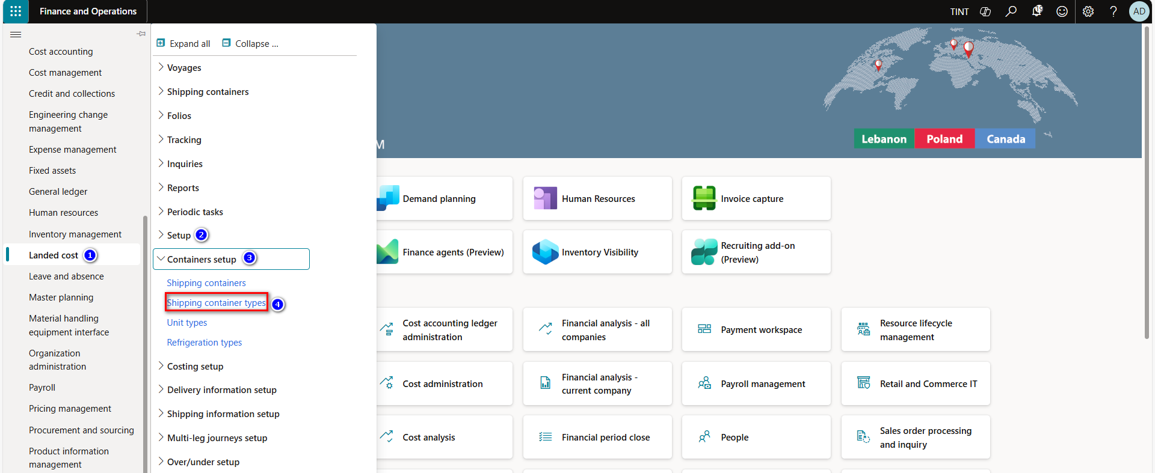

1. Press on new, to create a new shipping container type
2. Provide a code & a description of the shipping container type
3. In the general fast tab specify the maximum volume & weight that can be carried by containers of the container type

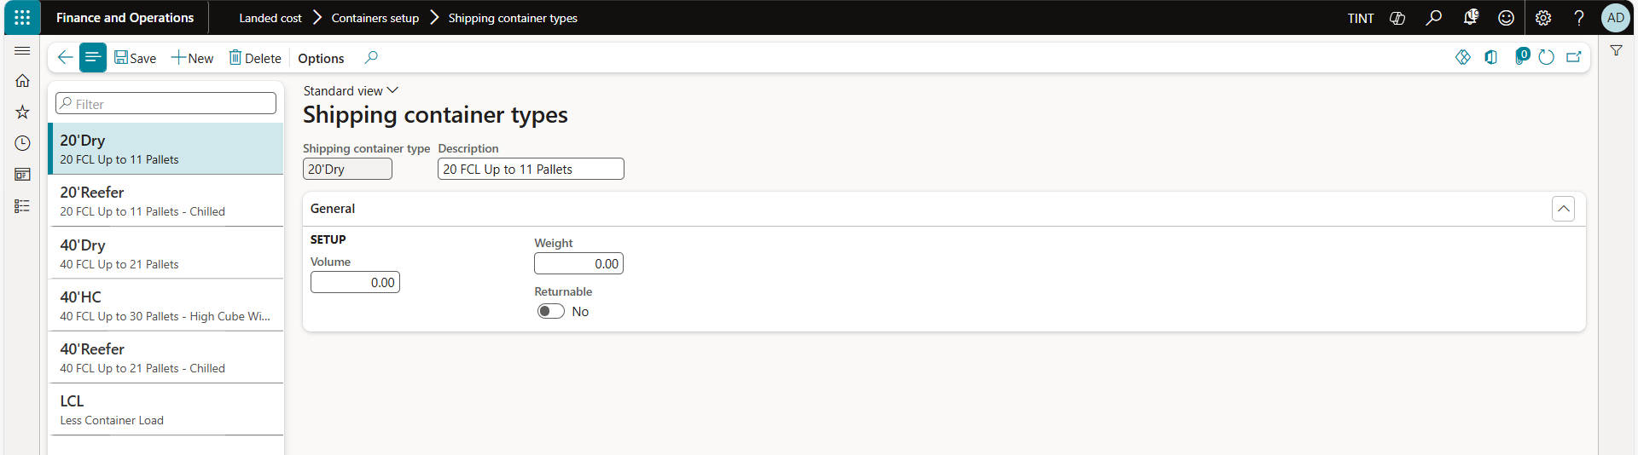

## 2.2 Shipping containers “Optional”

* **Shipping containers** store purchase order lines that are included in the voyage.

1. To access all shipping containers screen & define the required shipping containers, follow these steps: Landed cost > Setup > Containers setup > Shipping containers

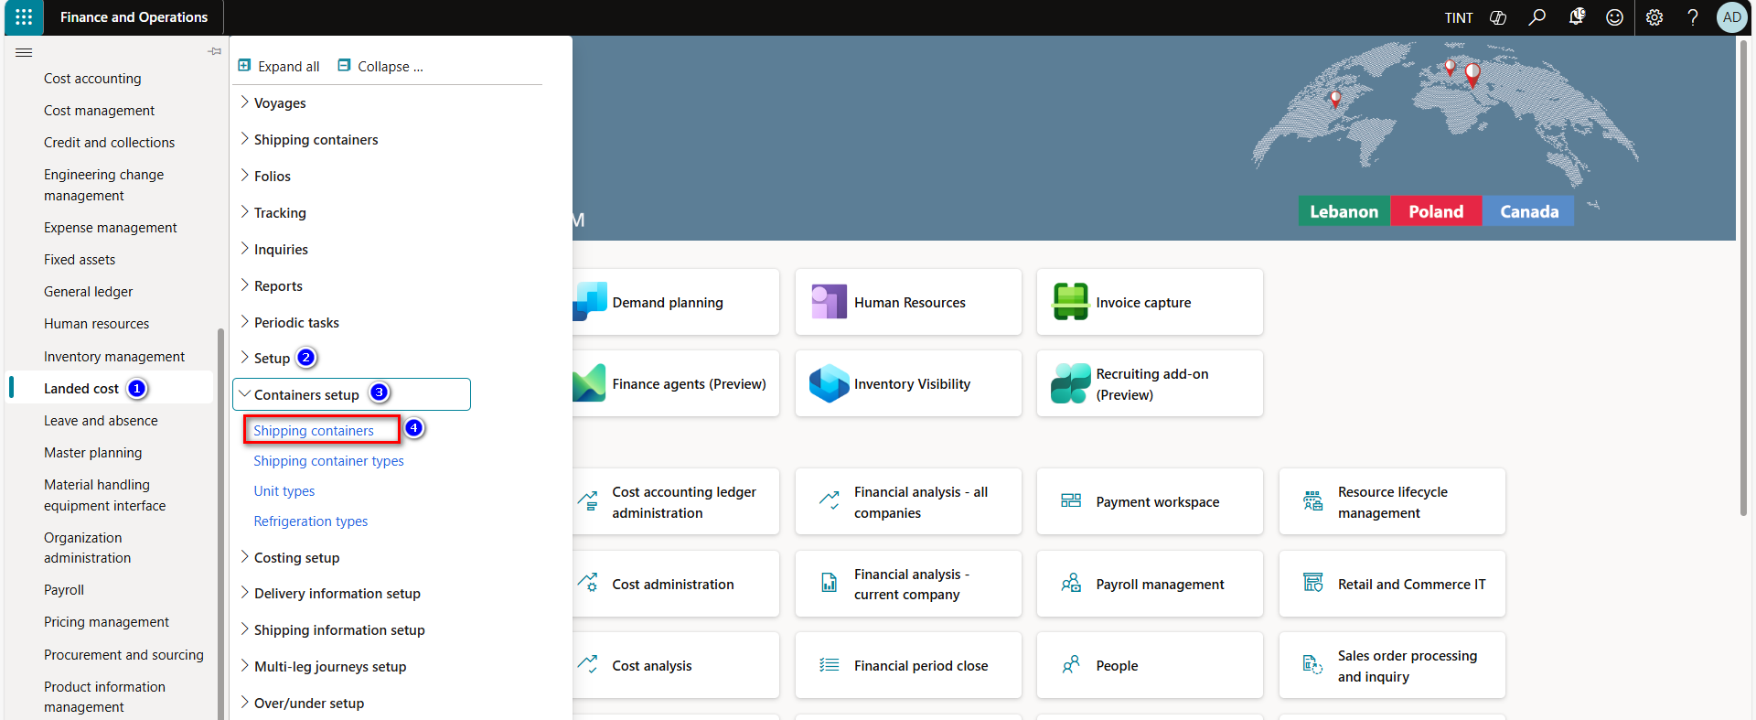

1. Press on new, to create a new shipping container
   * + 1. Provide the shipping container with a code & a description
       2. Select the shipping container type the shipping container is linked to

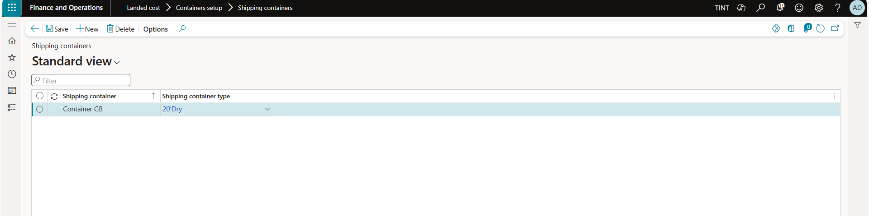

## 2.3 Shipping ports

Shipping ports identify where goods are being shipped from and to. For each voyage, you define a "to" port and a "from" port, based on the journey that you select for the voyage vessel. Shipping ports build the legs of a journey and the voyage activities. Typically, you define them by using the name of the city and the country/region where the physical shipping port is located.

1. Landed cost > Setup > Delivery information setup > Shipping ports

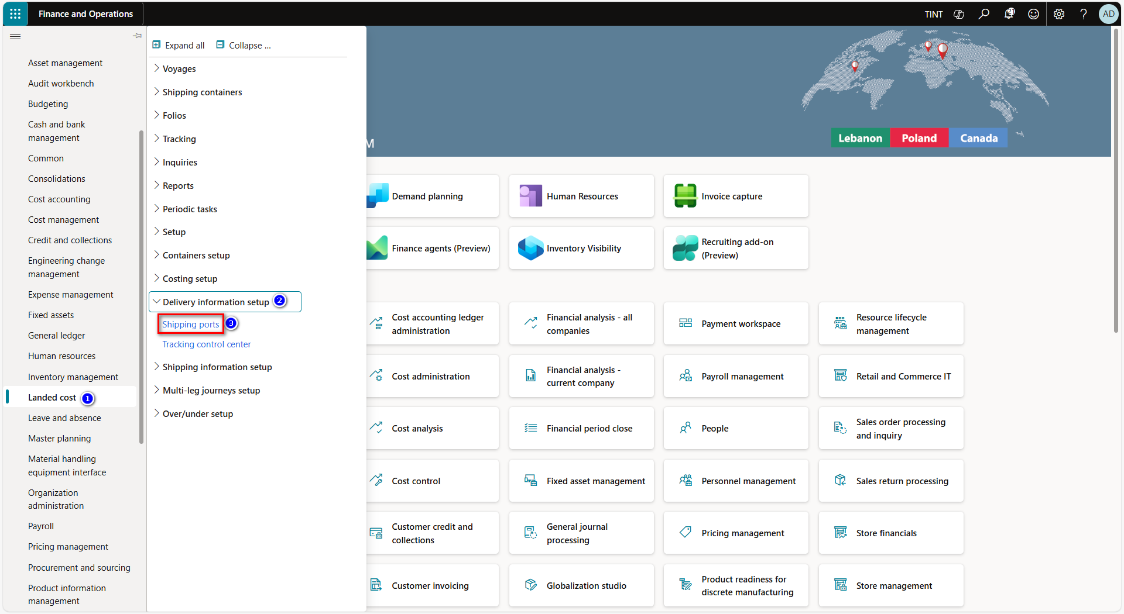

1. Press on new to create a new shipping port
2. Provide a unique code & a name for the shipping port

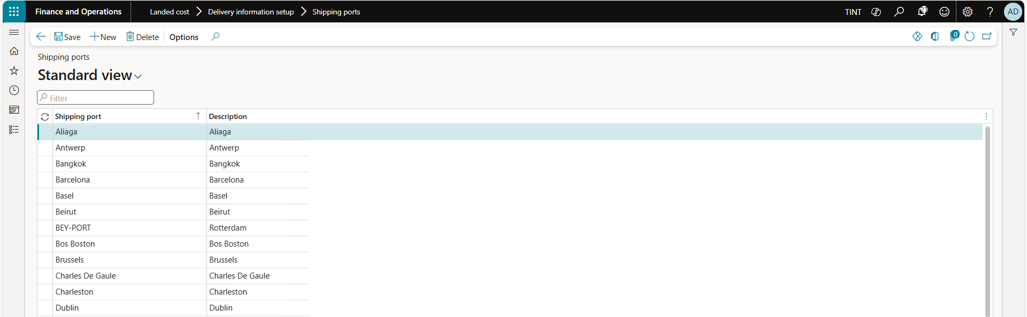

## 2.4 Vessels “Optional”

**Vessels** are the medium used for the transportation of goods in a voyage; it could be anything from a ship to a plane.

1. Landed cost > Shipping information setup > Vessels

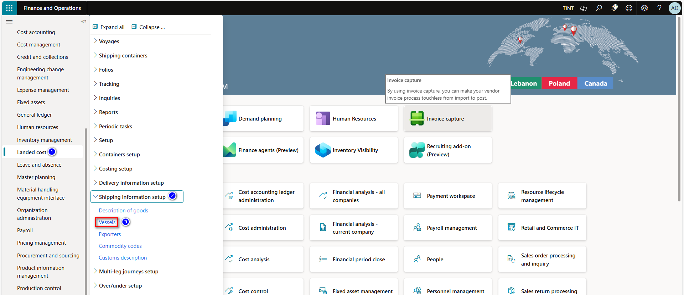

1. Press on new, to define a new vessel.
2. Provide the vessel with a code & a description.
3. Select the mode of delivery linked to the vessel.

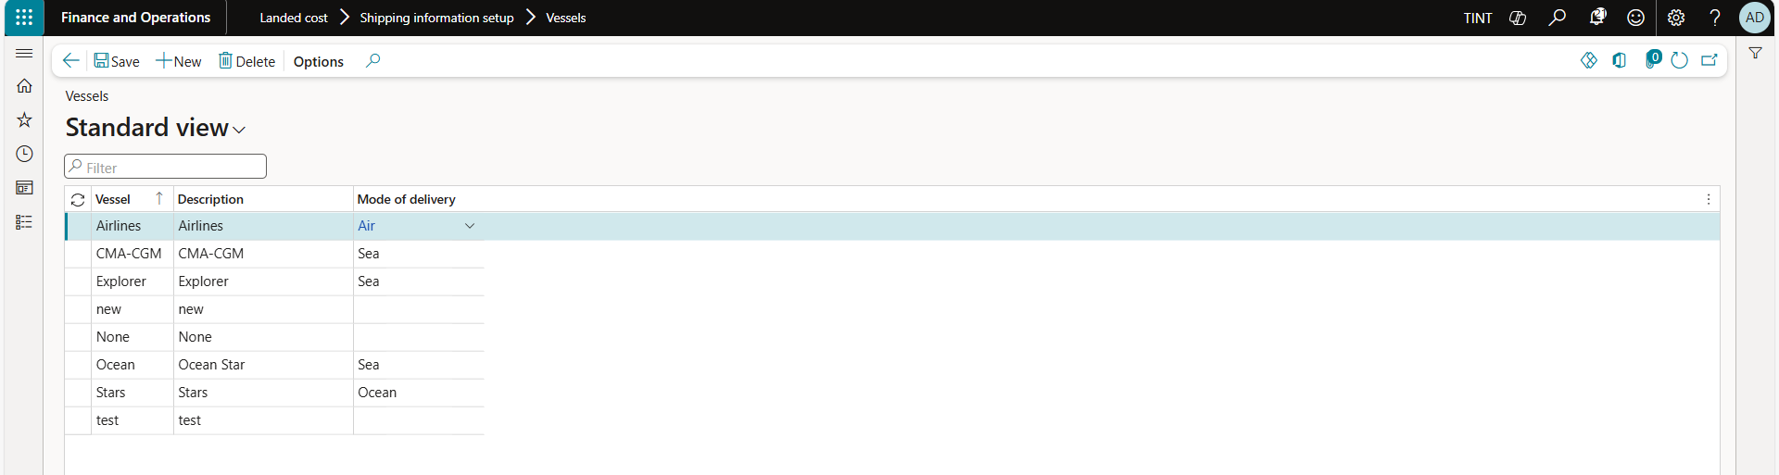

## 2.5 Legs

**Legs** are the different steps involved in the voyage & the process of shipping goods from the port of origin to the destination port.

1. Landed cost > Multi-leg journeys setup > Legs

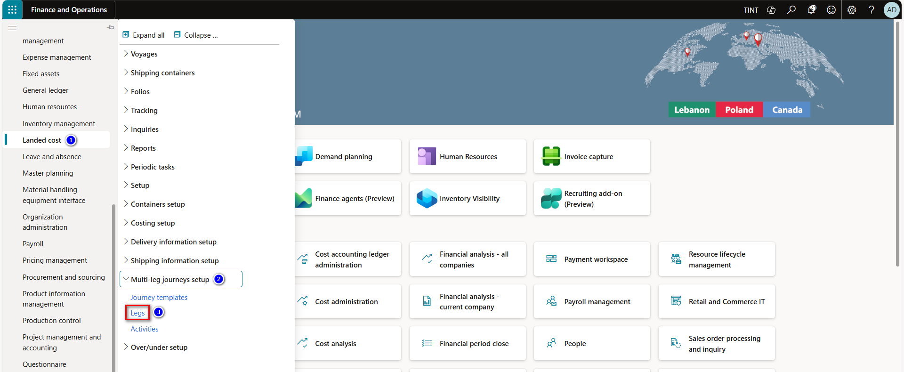

1. Press on new, to create a new voyage leg.
2. Provide the voyage leg with a code & a description.
3. Define the from port & the to port for the defined voyage leg.
4. In case the leg is an interim step other than sailing between the ports, define the ports as an.
5. Define the mode of delivery linked to the voyage leg.

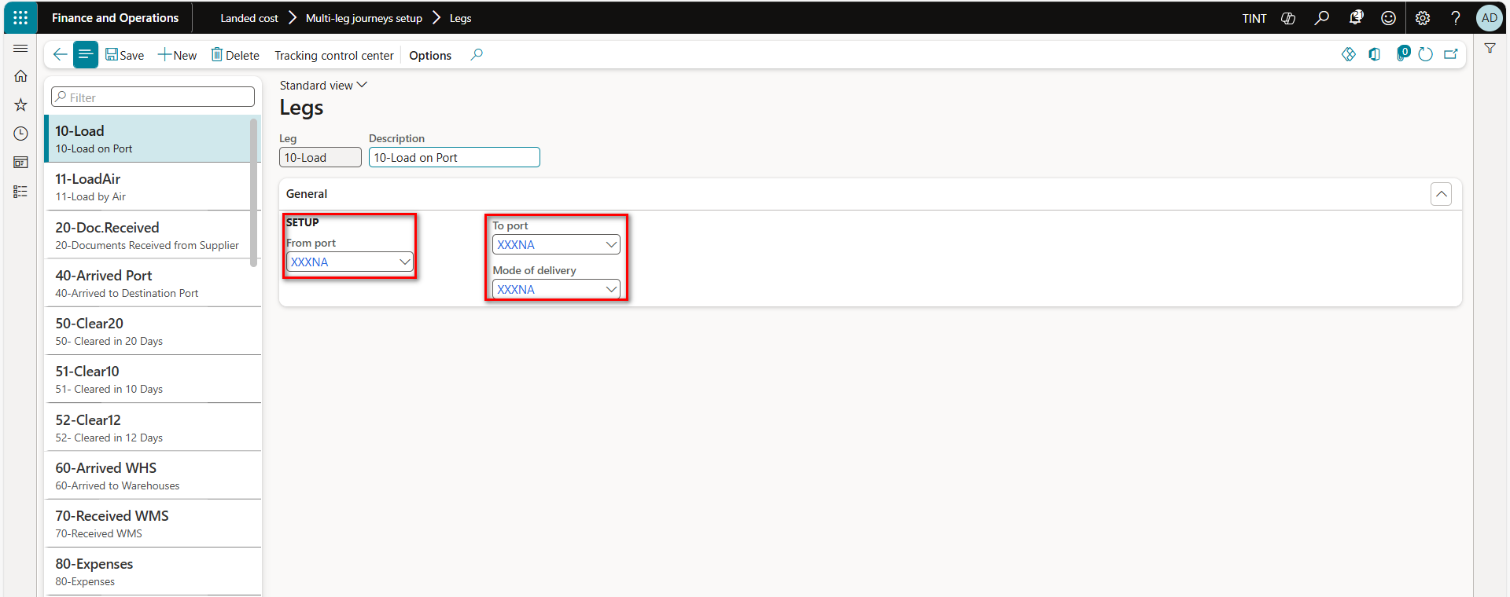

## 2.6 Activities

**Activities** are used to track significant steps of the journey between the moment the items are dispatched by the vendor until they are received into the warehouse. Activities can be paired with legs to update the tracking of a voyage & the voyage status.

1. Landed cost > Multi-leg journeys setup > Activities

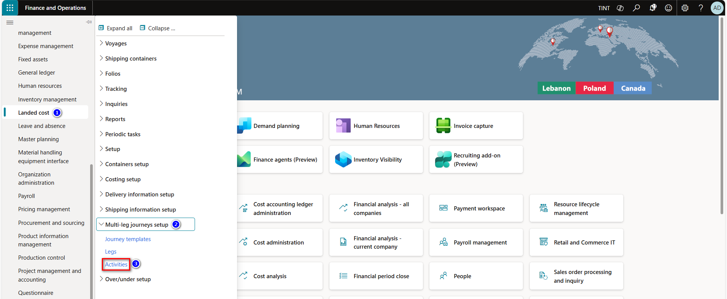

1. Press on new to create a new activity.
2. Provide a unique code & a name for the activity.
3. It is possible to link the activity to a shipping company.

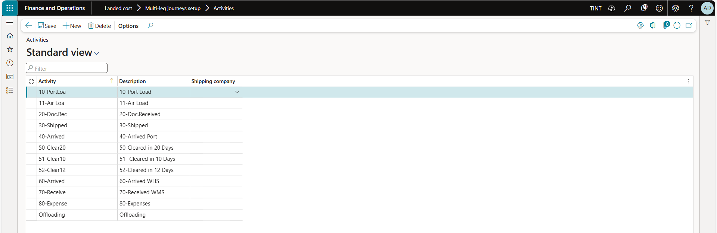

## 2.7 Cost type codes

**Cost type codes** are used to define the different landed cost charges involved in a voyage, & their financial impact.

1. Landed cost > Costing setup > Cost type codes

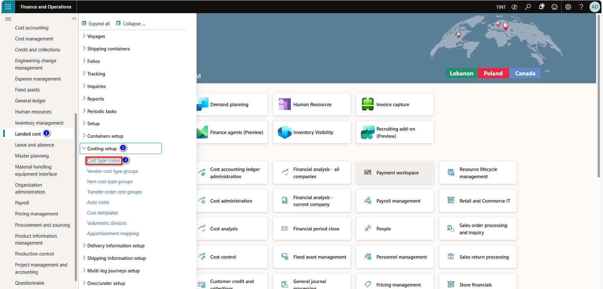

1. Press on new to create a new resource group.
2. Press on new, to define a new cost type code.
3. Provide the cost type code with a code & a description.
4. Select the reporting category.
   * 1. Used for categorizing cost type codes & displayed in reports related to landed cost charges.
5. Define the financial accounts for the cost type code.
6. Debit side | item - vendor - ledger account.
7. Credit side | item - vendor - ledger account.
8. Clearing account | account to hold estimated landed cost charges until actual values are known.

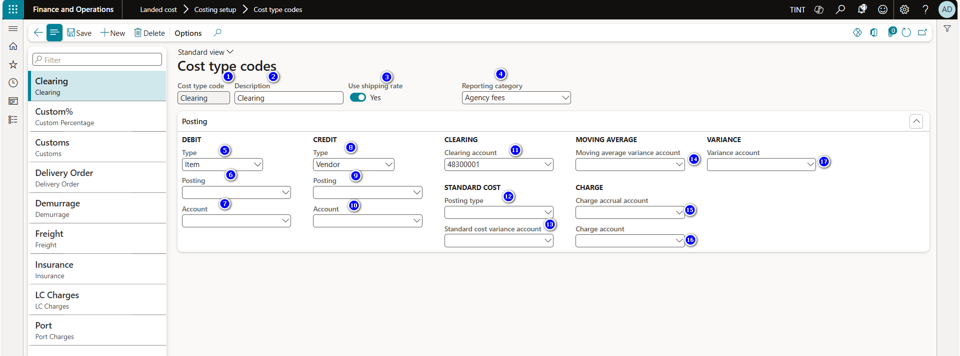

|  |  |  |
| --- | --- | --- |
| No. | Field | Description |
| 1 | Cost type code | Enter a name for the cost type code. |
| 2 | Description | Enter a description of the cost type code. |
| 3 | Use shipping rate | Set this option to Yes if the voyage exchange rate (sometimes referred to as a management rate) must be used to calculate the value of these costs. In this case, the shipping rate is used instead of the standard default or spot exchange rate to exchange foreign currency invoices. |
| 4 | Reporting category | This field establishes a reporting category for the cost type. You can print reports either by reporting categories or by cost type. |
| 5 | Debit type | Select whether the cost type should debit the item, the ledger account, or the vendor. |
| 6 | Debit posting | If you set the **Debit type** field to Ledger account, select the posting description. |
| 7 | Debit account | If you set the **Debit type** field to Ledger account, select the ledger account to use. |
| 8 | Credit type | Select whether this cost type should credit the item, the ledger account, or the vendor. |
| 9 | Credit posting | If you set the **Credit type** field to Ledger account, select the posting description. |
| 10 | Credit account | If you set the **Credit type** field to Ledger account, select the ledger account to use. |
| 11 | Clearing account | Select the clearing account for the cost type. Specify a separate clearing account per cost type to help with reconciliation. |
| 12 | Standard cost posting type | If you're using standard costing, select the posting description. |
| 13 | Standard cost variance account | If you're using standard costing, the account that you specify here is used to post any variance. This account uses the landed cost breakdown on the **Item prices** page. This breakdown is created by using the periodic routine to update prices.  For example, the standard cost of an item is $15.00, the FOB is $13.00, and the freight is $2.00. When you receive the invoice for the stock, you receive the item at $15.00, but there's a standard price variance of $2.00 for the item, because the actual FOB is $13.00. This variance is posted to the standard price variance account that is set up in the item posting profile. Because the estimated freight price is $2.00, there's no variance when the stock invoice is posted. However, when you receive the invoice for freight, the price of freight is $2.50 per unit. Therefore, a $0.50 variance is posted to the specified cost. |
| 14 | Moving average variance account | If you're using moving average costing, the account that you specify here is used to post any variance.  For example, the estimated freight cost is $2.00. However, when you receive the invoice for freight, the price of freight is $2.50 per unit. Therefore, a $0.50 variance must be posted.  When you set the **Post adjustments as variance** option to Yes on the **Landed cost parameters** page, all variances between estimated and actual shipment costs are posted to the moving average variance account that you specify here. When you set the **Post adjustments as variance** option to No, standard functionality is used, and the variance is applied either to inventory or to the moving average variance account that you specify here, depending on stock on hand. |
| 15 | Charge accrual account | Select the account that is used to accrue for cost estimates when the purchase invoice is posted. This field is used only when the **Use cost type charge accrual account** option is set to Yes on the **Costing** Fast Tab on the **General** tab of the **Landed cost parameters** page. |
| 16 | Charge account | Select the account that is used to capture the inbound transportation costs that a supplier invoiced. The amount is posted as a debit. The offset account is the stock variation account. This posting is used only when the **Post to charge account in ledger** option is set to Yes on the **Accounts payable parameters** page. |
| 17 | Variance account | The account that offsets the charge accruals when the purchase invoice is posted. This field is used only when the **Use cost type charge accrual account** option is set to Yes on the **Costing** Fast Tab on the **General** tab of the **Landed cost parameters** page. |

## 2.8 Auto cost

**The auto cost screen** is used to define & set up cost rules for various cost areas such as voyages & shipping containers. Based on the defined rules & the estimated cost values for each cost type code, the system will automatically apply the defined cost values to the voyage upon creation, determining the overall estimated landed cost per cost area.

1. Landed cost > Costing setup > Auto cost

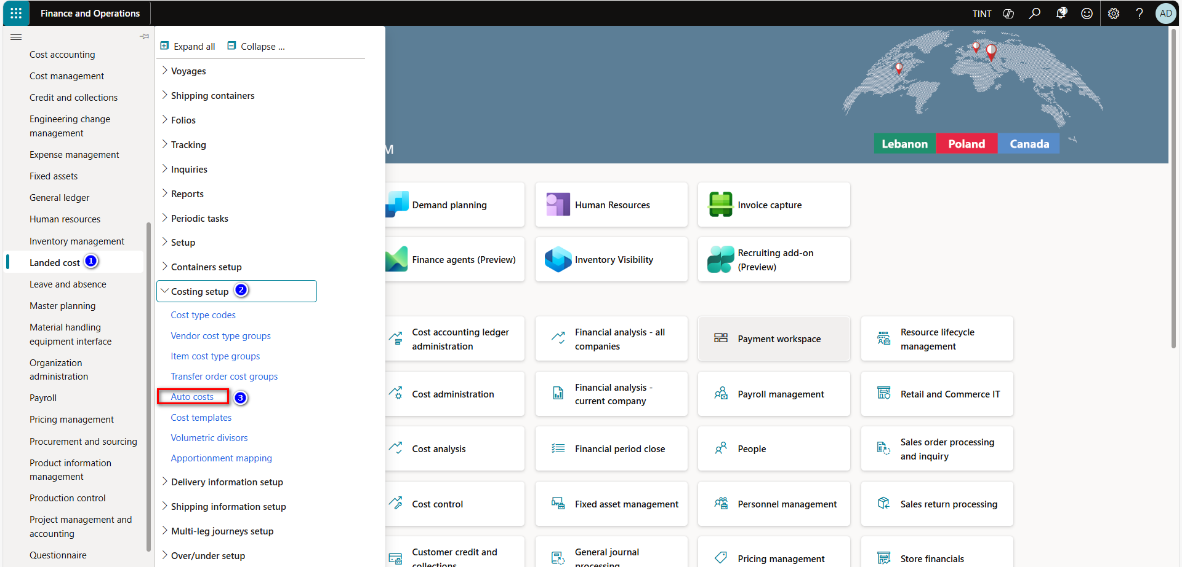

1. In the cost area field, select the cost area.
   1. Voyage - item - shipping container - folio - purchase order.
2. Press on new, to create a new auto cost.
   1. In the account table choose one of the following:
      1. Table - cost rule applies to a specific vendor.
      2. Group - cost rule applies to a specific vendor group.
      3. All - cost rule applies to all vendors.
   2. Selecting the shipping company the cost rule applies to | filtering criteria.
   3. Selecting the mode of delivery the cost rule applies to | filtering criteria.
   4. Selecting the from & to ports the cost rule applies to | filtering criteria.
3. In the lines fast tab, lines for the cost rule & define the following:
   1. Select the cost type code.
   2. Select the apportionment method used to distribute costs to voyage lines.
      1. Percent - percentage of the total value of goods.
      2. Quantity - cost is apportioned based on the quantity of goods.
      3. Amount - cost is apportioned based on the value of goods.
      4. Volume - cost is apportioned based on the volume of goods.
      5. Weight - cost is apportioned based on the weight of goods.
      6. Volumetric - cost is apportioned based on the volumetric measurement of goods.
      7. Measurement - this option enables a measurement to be specified in the landed cost module.
   3. Specify the validity period of the auto cost.
   4. Select the category used to calculate costs.
      1. Fixed - cost is apportioned based on the apportionment method.
      2. Pieces - cost will be allocated per piece - apportionment method is ignored.
      3. Percent - a percentage of the goods’ value will be added - apportionment method is ignored.
      4. Rate - used with quantity breaks - apportionment method should be set to measurement.
   5. Enter the cost value | estimated cost of the landed cost charge.
   6. Select the currency of the cost value.
   7. Select the tax code for the auto cost – optional.

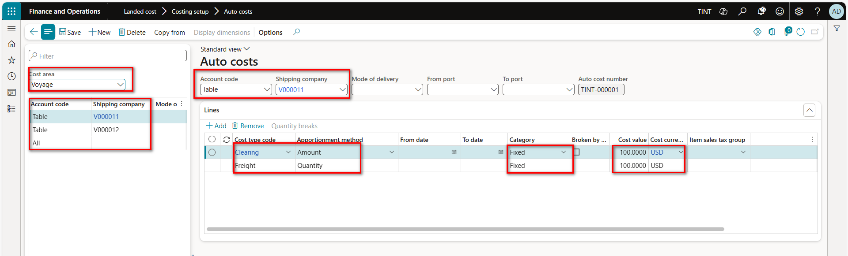

## 2.9 Voyages status

Voyage status allows users to assign a status to the voyage. It is used to inform the user about the status of the voyage.

1. Landed cost > Setup > Voyage statuses

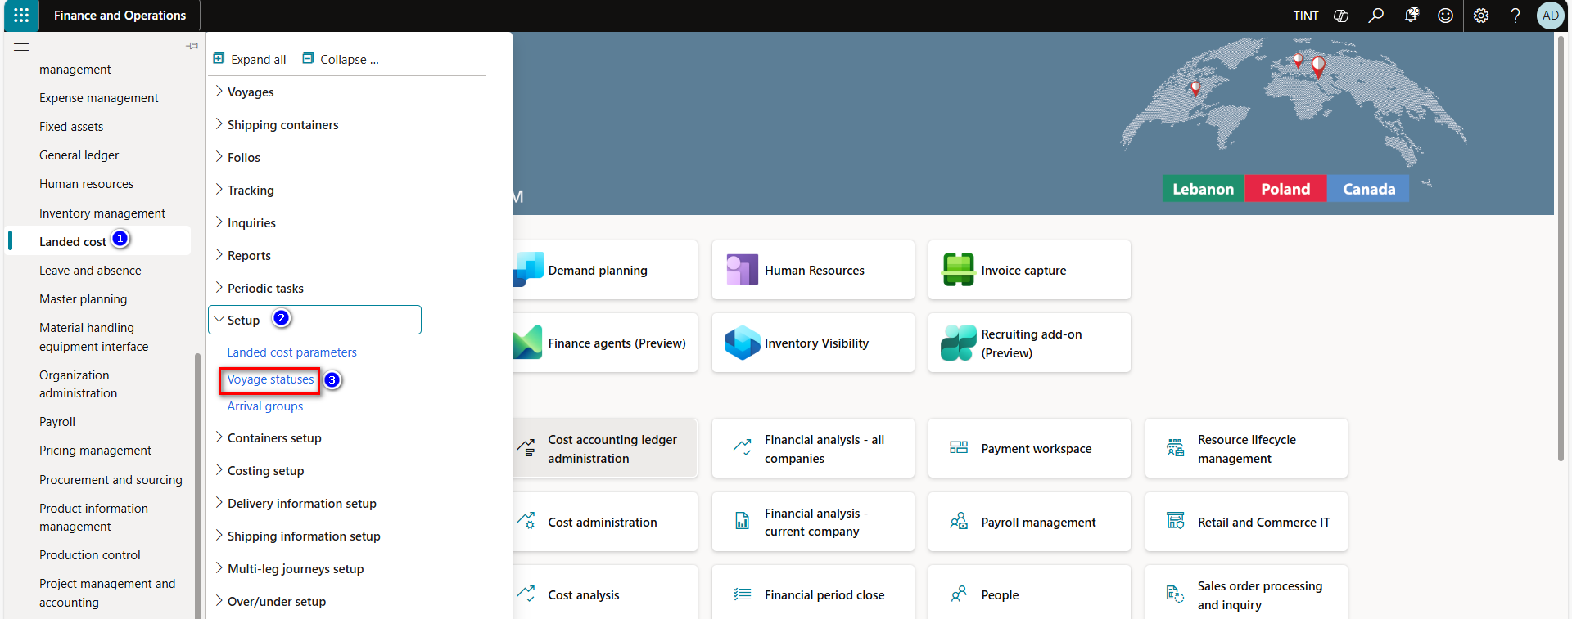

1. In the cost area field, select the cost area to define voyage statuses for.
   1. Voyage - item - shipping container - folio - purchase order.
2. Press on new, to define a new voyage status.
   1. Provide the voyage status with a code & a description.
   2. Specify the actions that can be done on the voyage legs.
      1. Modify - specify if users are allowed to modify voyages having this status.
      2. Delete - specify if users are allowed to delete voyages having this status.
      3. Mandatory - specify that this voyage status is mandatory & can’t be skipped.
   3. Parent - establish a hierarchy among the voyage statuses.

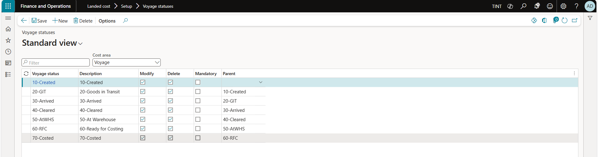

## 2.10 Journey template

**Journey templates** are used to define & group the steps included in a single voyage between a defined pair of ports.

1. Landed cost > Multi-leg journeys setup > Journey templates

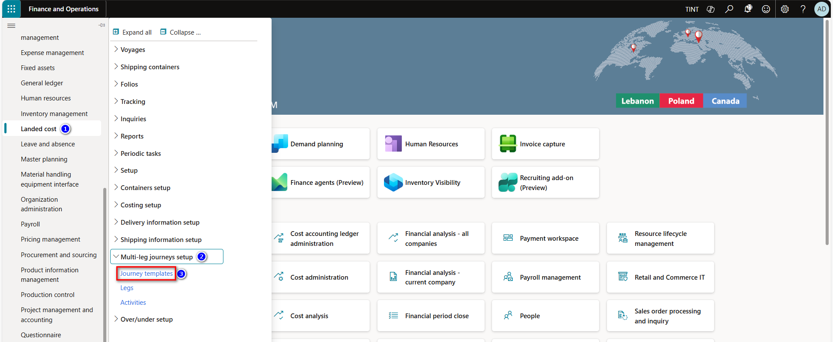

1. Press on new, to create a new BOM, & provide it with a description.
2. Press on new, to create a new journey template.
   1. Provide the journey template with a code & a description.
   2. Select the legs to add to the journey template.
      1. Define the selection of legs in their respective order.
   3. The from port, to port, & mode of delivery are automatically populated according to the leg’s setup.
   4. In case the leg contains the from port & the to port check the journey from port & journey to port checkboxes.
   5. In case a specific shipping company is associated with the leg select it in the shipping company field.

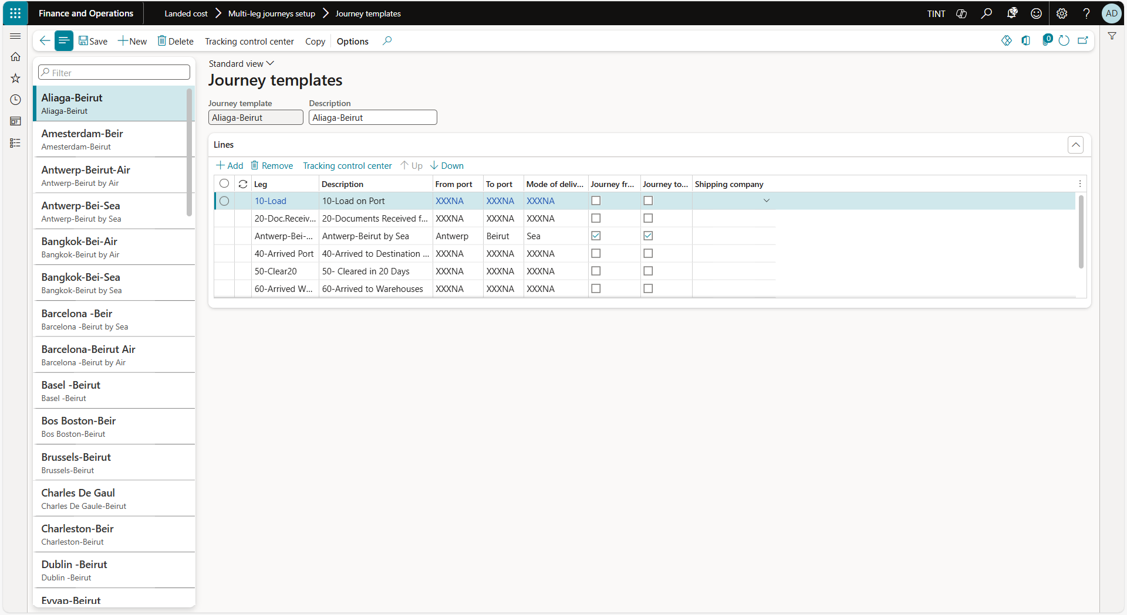

## 2.11 Tracking control center

**The tracking control center** can be used to set up the lead times, status updates, & the flow of information associated with a voyage, as the shipping containers move from one leg to another. The tracking control center can be used to specify the estimated lead time per leg, the voyage status to be assigned to a voyage once a specific leg & activity are completed, the dates to be updated according to the estimated & actual start & end dates of a specific leg within the voyage’s journey template.

1. Landed cost > Setup > Delivery information setup > Tracking control center.

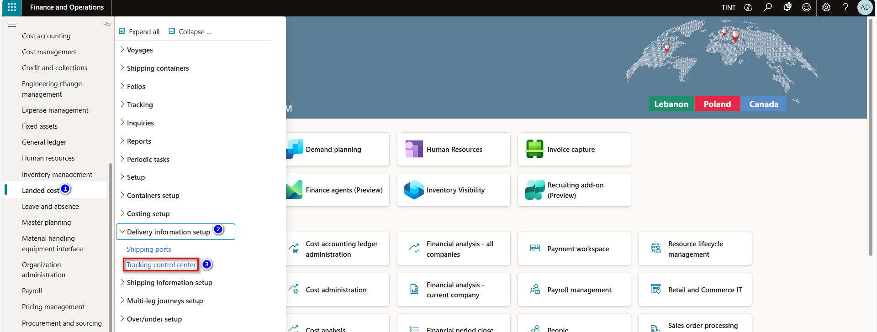

1. Select the create type | area within the tracking control center.
   1. Blank - lead time - status update.
   2. Different create types update a different set of information associated with the progress of a voyage.
2. On the blank create type | specify the field update between tables on the voyage & the purchase order.
   1. Source field & source table - identify a source field & source table in the database.
   2. Target field & target table - identify a destination field & table in the database.
   3. Activity - identify the activity type applied to the shipping containers matched by the rule.
   4. Leg - identify the leg of the journey the specified action occurs for.

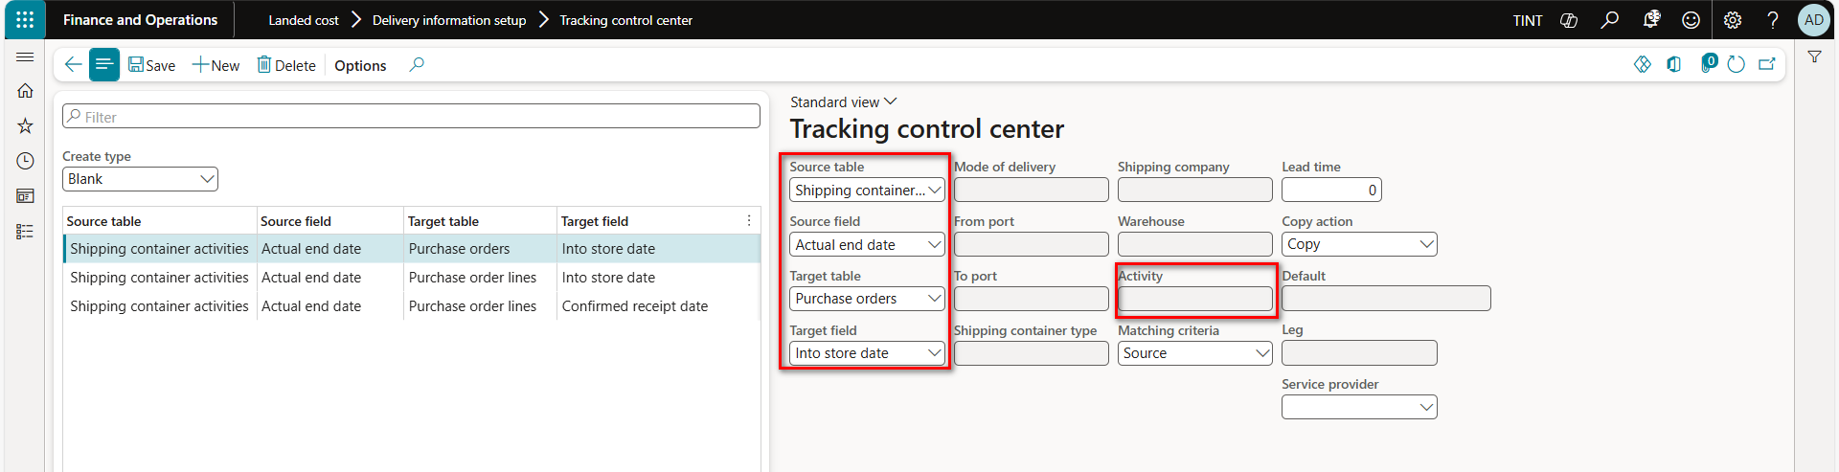

1. On the lead time create type | specify the estimated lead time required to complete a voyage leg.
   1. Lead time automatically applied to the voyage leg when the criteria are met on a voyage.
   2. Activity - identify the activity type applied to the shipping containers matched by the rule.
   3. Leg - identify the leg of the journey the specified action occurs for.
   4. Lead time - specify the estimated lead time of a voyage leg.

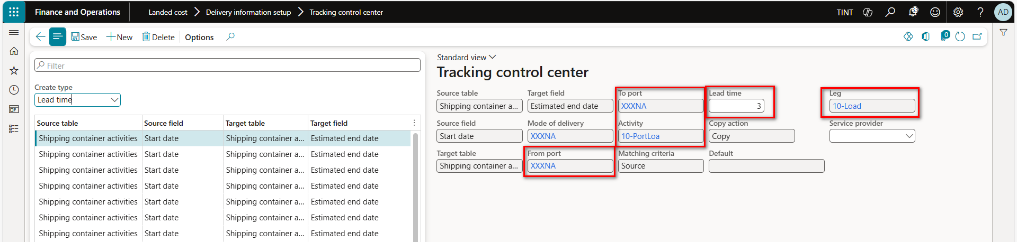

1. On the status update create type | specify when the voyage status should be updated.
   1. Voyage - shipping container - item - purchase order - purchase order lines – folio.
   2. Specify the leg & the activity the voyage status should be updated upon completion.
   3. Specify the voyage status to be assigned once the defined leg & activity are completed.

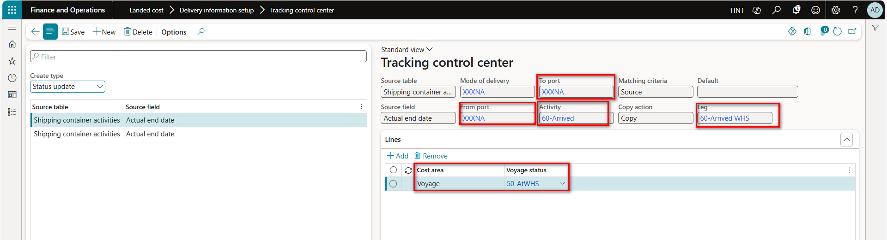

# 3.0 Landed cost processes

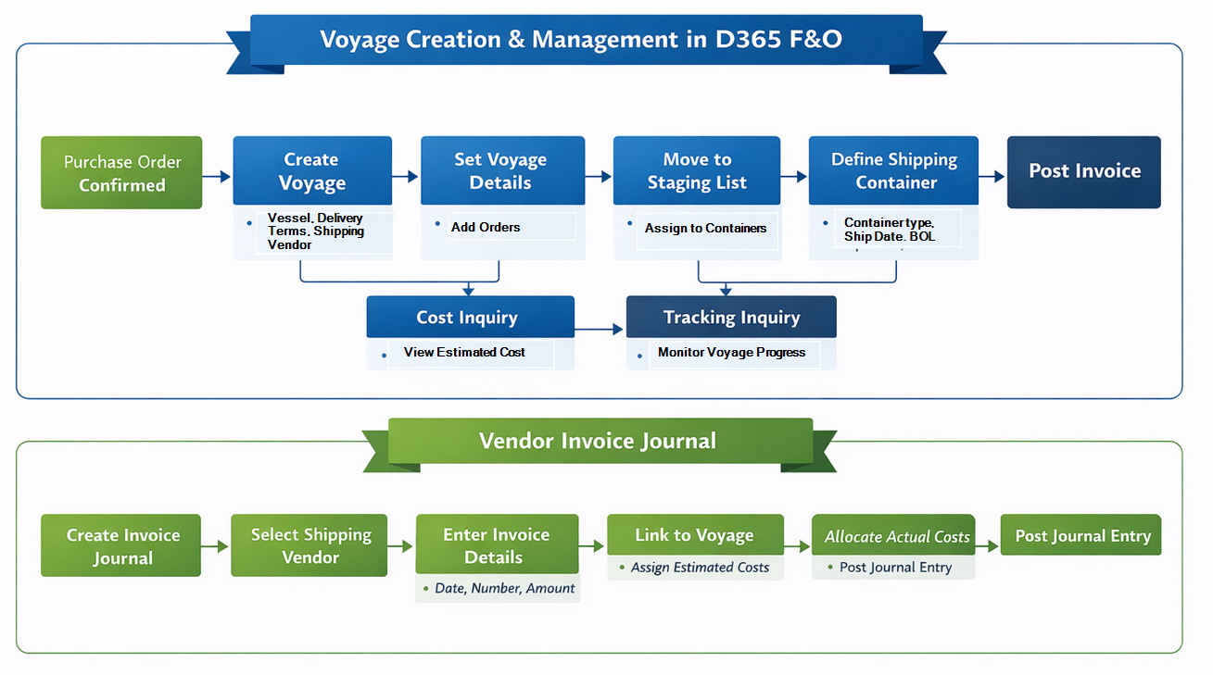

## 3.1 Voyages

Once a purchase order has been confirmed & the shipping documents are received from the supplier, the voyage can be created & products can be added to the shipping containers according to the containerization process.

Once the purchase is confirmed, the voyage can be created from purchase order.

1. Procurement and sourcing > Purchase orders > All purchase orders

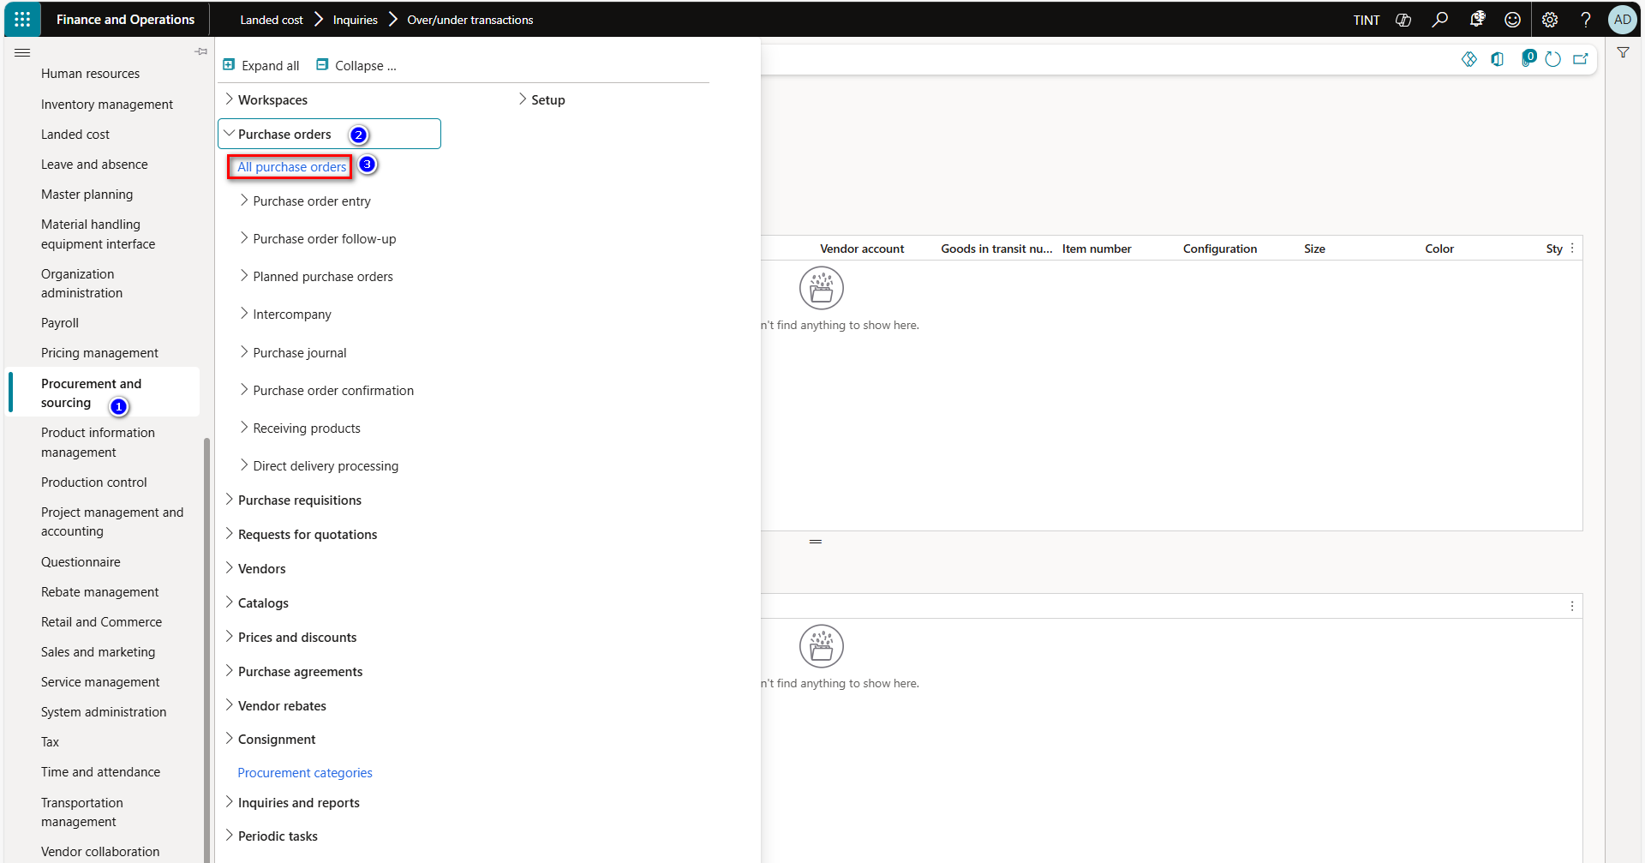

1. Before creating a voyage from the purchase order make sure of the following:
   1. Matching policy is turned off for the vendor.
   2. Delivery terms assigned have the goods-in-transit management checkbox marked.
2. On the purchase fast tab, click on create new voyage from the landed cost section.

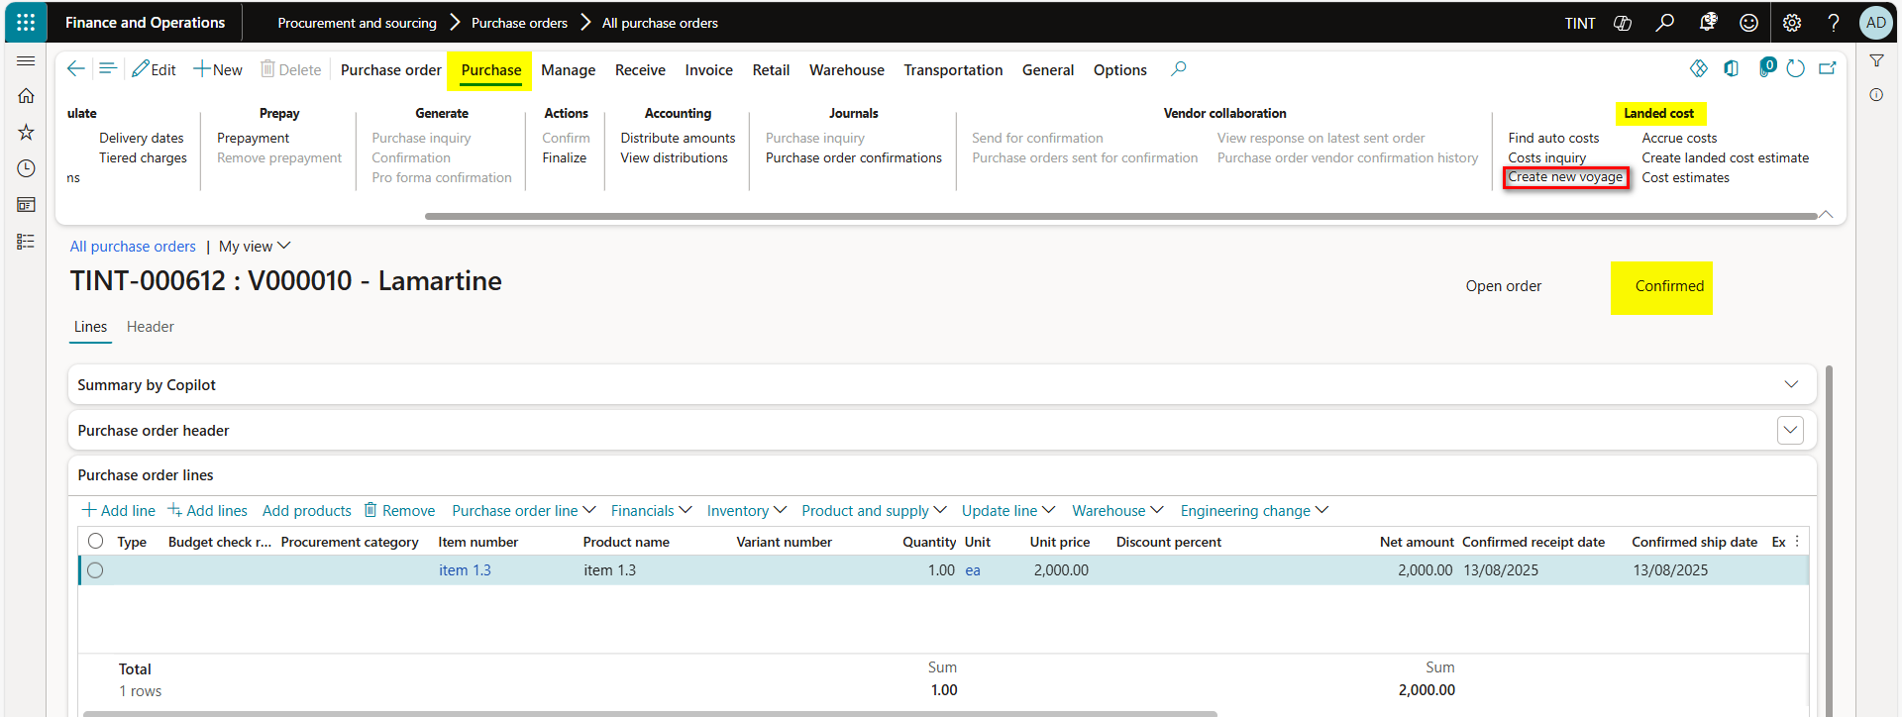

1. The voyage is automatically assigned a code according to the defined number sequence.
2. On the create voyage pop-up screen define the following:
   1. Provide the voyage with a description
   2. Define the vessel used for the voyage | select or define a value
   3. Specify the journey template & the mode of delivery used for the voyage
   4. Specify the shipping company vendor responsible for delivery | defaulted on the vendor

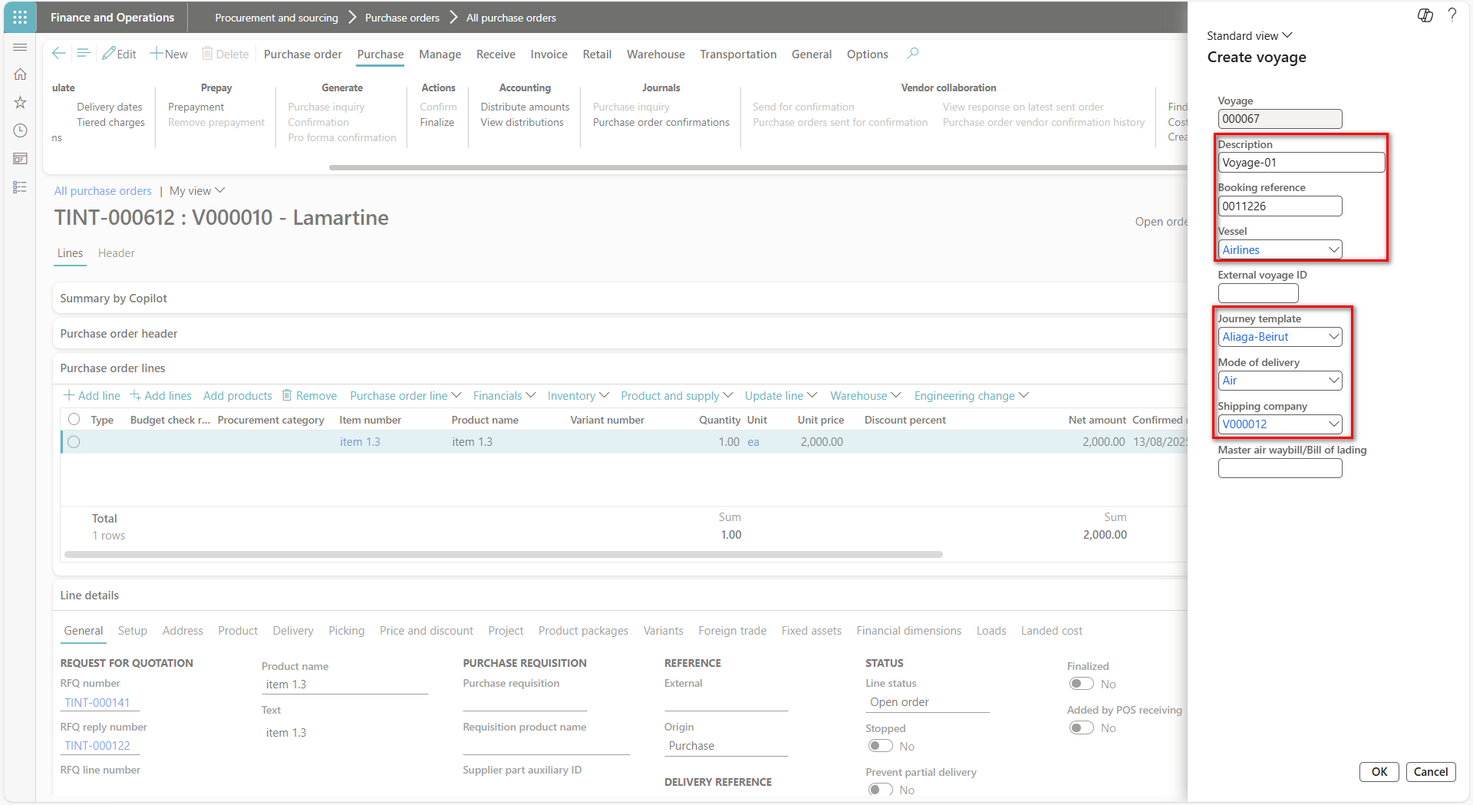

1. On the voyage editor screen, you can set specific filtering criteria for displaying purchase orders.
2. In the inbound orders fast tab.
   1. Purchase orders matching the defined criteria are displayed
   2. Purchase orders can be selected to be added to the voyage by marking on the header
3. In lines to select fast tab.
   1. Select the purchase order lines & quantities to be included in the voyage
   2. Click on add to staging list then view staging list to add products into shipping containers
4. The purchase quantity, inventory quantity, volume, & weight are displayed for each purchase order line.

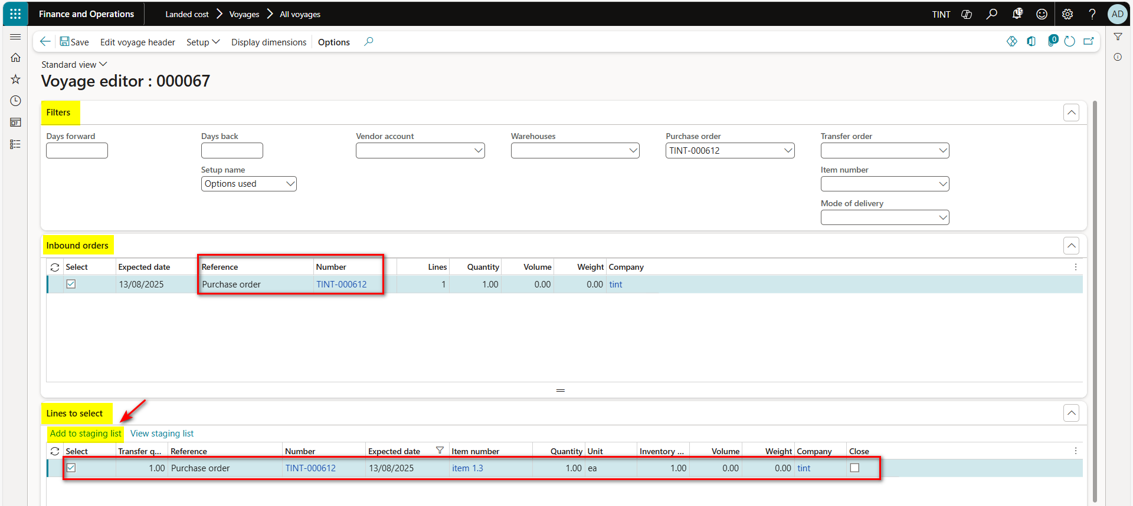

1. On the staging list, the compiled list of purchase order lines to be included in the voyage is displayed.
   1. Select the purchase order lines & the quantity to add into the shipping container
2. On the shipping container pop-up screen.
   1. Select or define the shipping container code
   2. Select the shipping container type
   3. Define the ship date & the bill of lading.
3. In case the quantities exceed the maximum container capacity.
   1. Purchase order lines are removed from the staging list

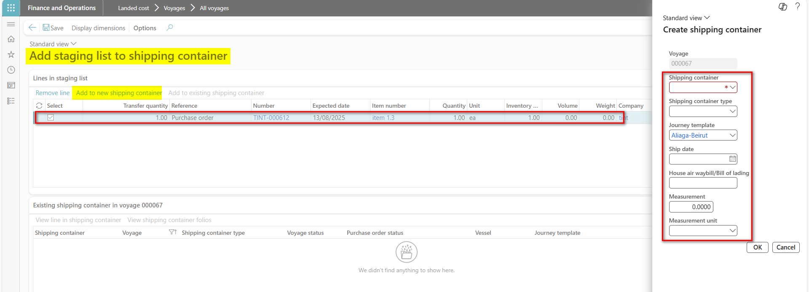

1. The created voyage is automatically assigned the status created.
2. Click on post invoice from the purchase order section on the manage fast tab.
   1. Post purchase order invoice

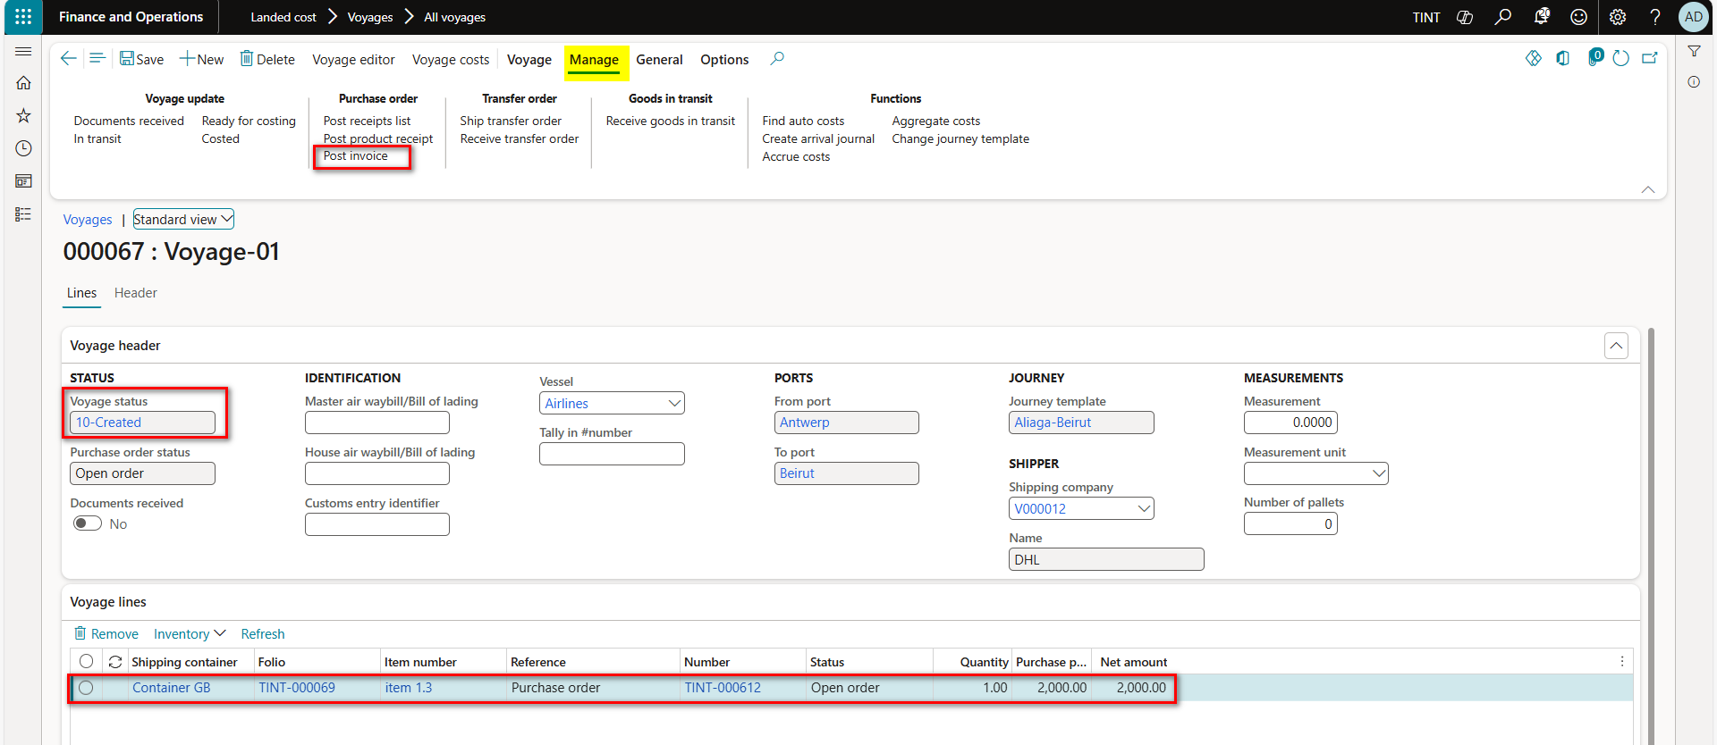

1. To access the voyage cost inquiry screen.
   1. Click on costs inquiry from the general fast tab
   2. The estimated costs per cost type code & product are displayed
   3. The view button can be used to customize the view of the screen
   4. Actual costs are set to 0 since the actual voyage costs haven’t been accrued yet

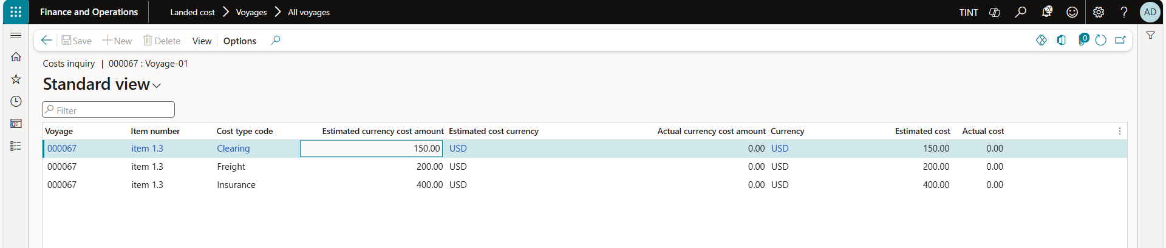

1. To access the tracking inquiry screen.
   1. Click on tracking on the general fast tab
   2. Legs & their respective activities are listed with their estimated lead time according to the tracking control center
      1. The start date & end date per leg & activity combination can be updated
      2. According to the progress defined in the tracking screen, the voyage status is updated accordingly

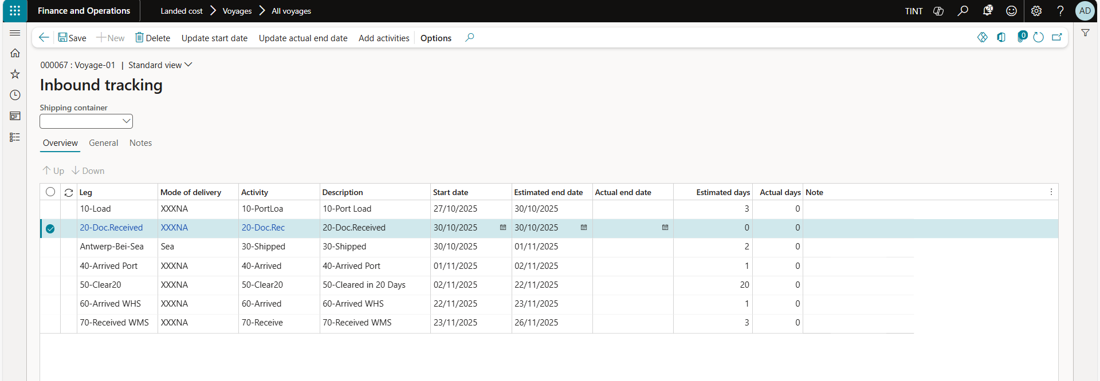

1. In case of multiple Pos that need to be shipped into one voyage. Navigate to landed cost > all voyages. Create a new voyage, provide the vessel name and other needed information and press OK,
2. Select the list of purchase orders then add to staging list and do the same steps explained earlier.

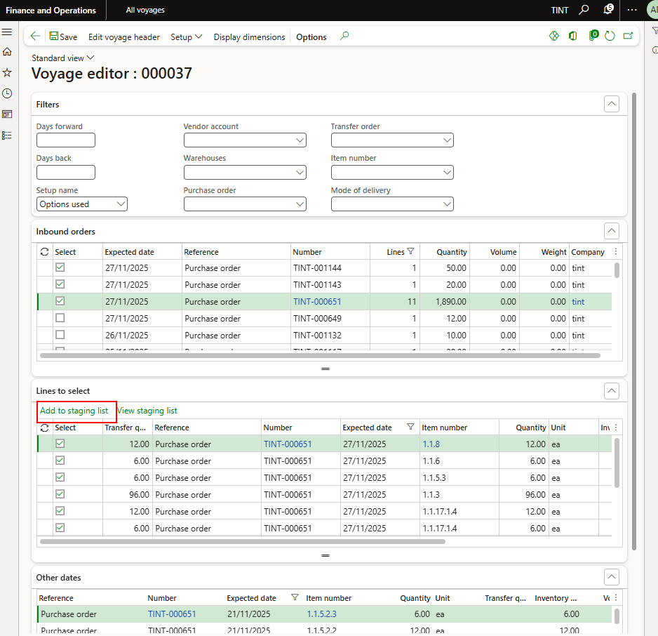

## 3.2 Invoice journal.

Vendor invoice journals are created to accrue the actual landed cost charges to either vendors or ledger accounts.

1. Go to Accounts payable > Invoices > Invoice journal.

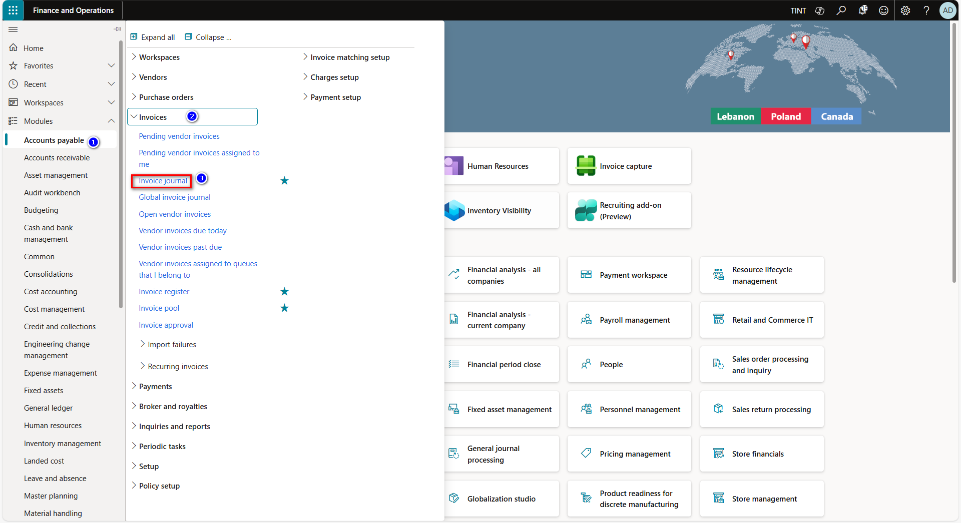

1. Press on new to create a new vendor invoice journal.
2. Specify the journal name & click on the lines button to open the vendor invoice journal lines.

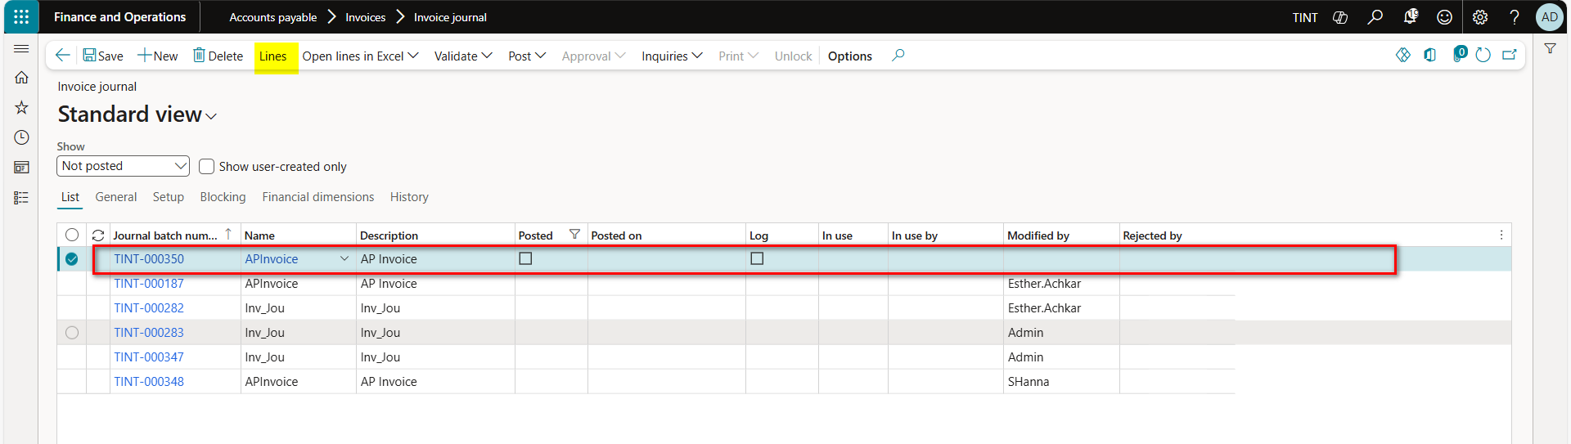

1. In the account type select vendor & define the vendor account.
   1. The vendor account should be specified as the shipping company vendor account.
2. Specify the invoice date & invoice number.
3. Specify the total invoice amount in the credit field.
4. Click on the function’s dropdown menu, then select voyage costs.
   1. Choose the voyage from the dropdown menu.

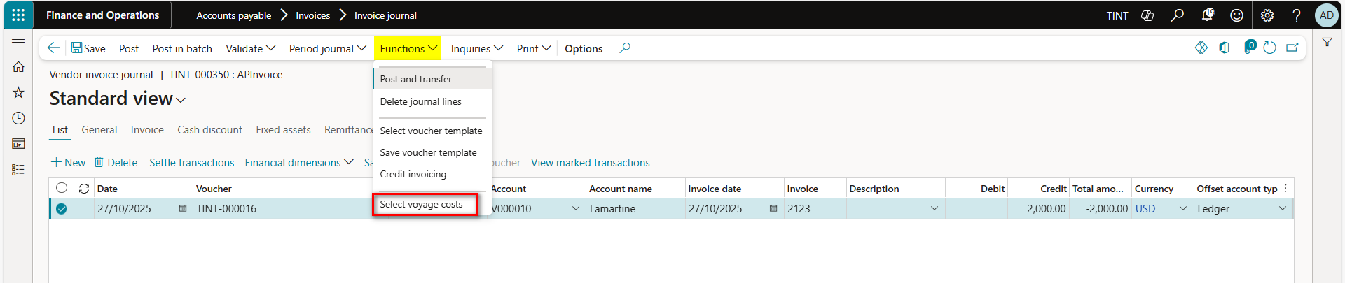

1. For each cost type code, the estimated cost amount is specified
   1. Allocate the actual cost amount per cost type code
2. Once the complete cost is allocated post the vendor invoice journal

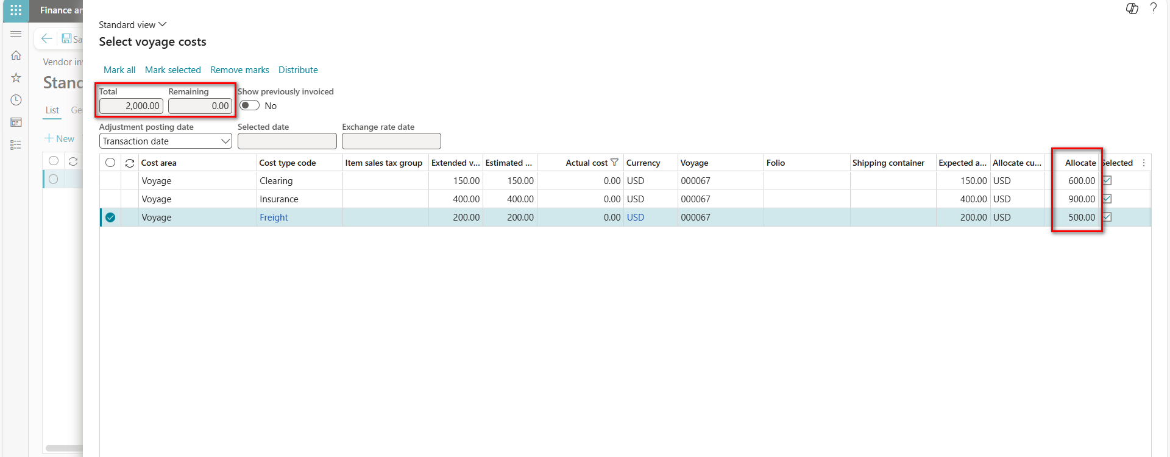

# 4.0 Landed cost reports

## 4.1 Voyage lines.

The Voyage Lines report provides detailed information about all lines associated with a specific voyage in the Landed Cost module. It includes data on containers, purchase orders, items, quantities, and shipment details linked to each voyage.

Landed cost > Inquiries > Voyage lines.

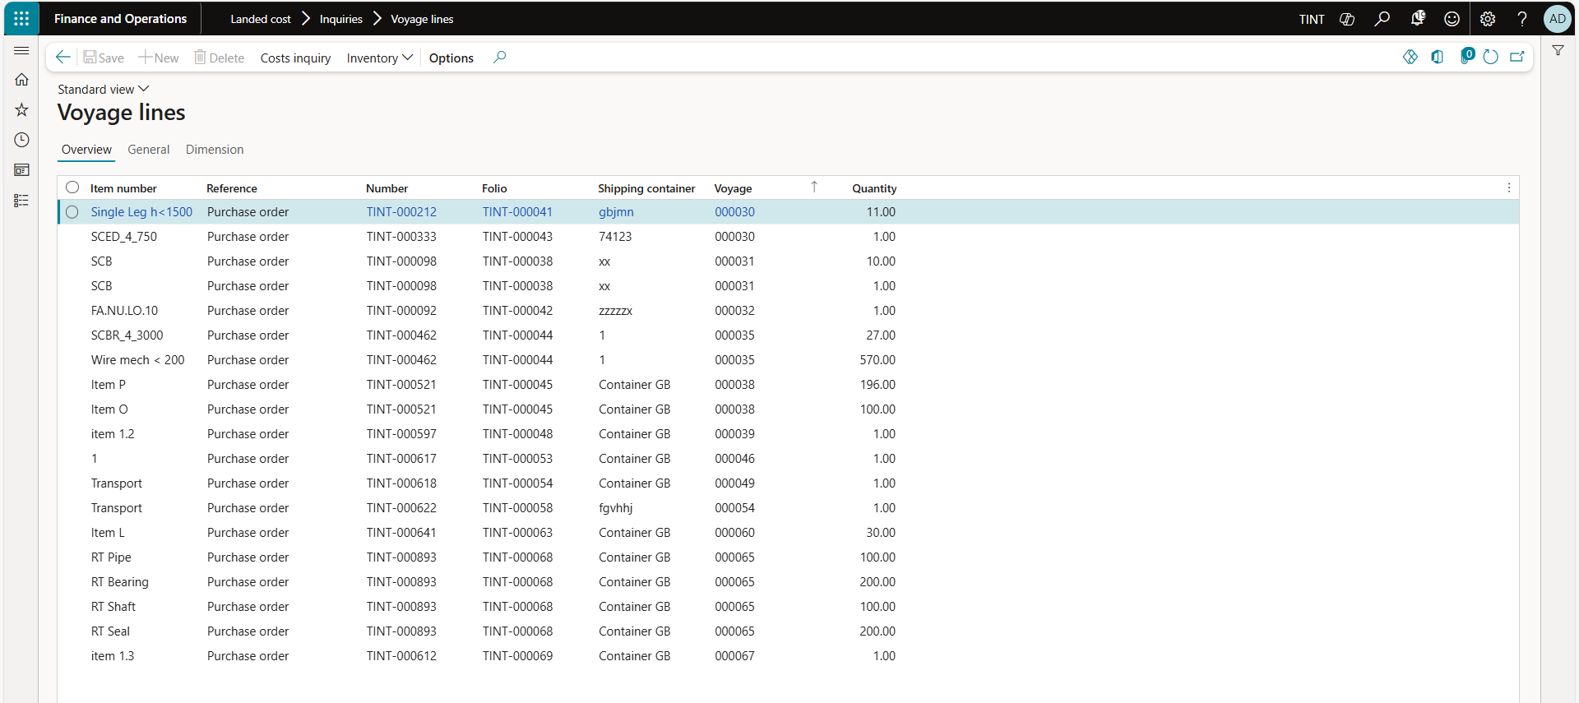

## 4.2 Voyage costing by individual cost.

The Voyage Costing by Individual report provides a detailed breakdown of costs associated with each individual voyage, including freight, duties, insurance, handling, and other landed cost components.

Landed cost > Reports > Costing > Voyage costing by individual cost.

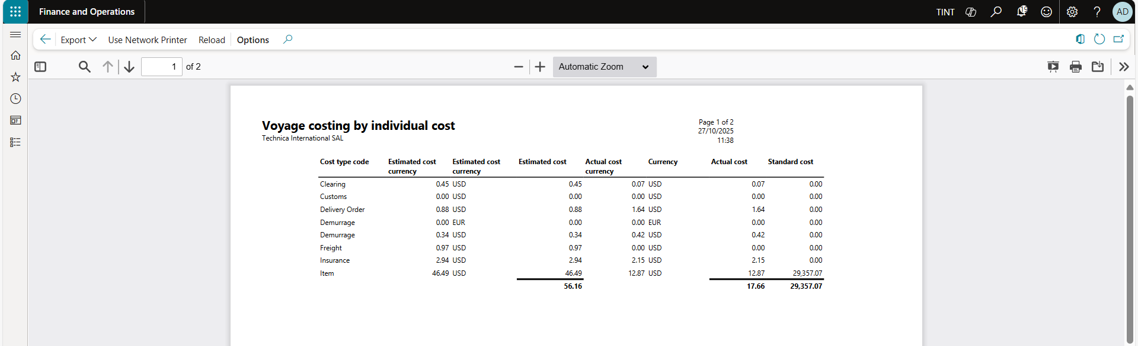

## 4.3 Voyage costing by reporting category.

The Voyage Costing by Reporting Category report summarizes voyage-related costs grouped by predefined reporting categories, such as freight, customs, insurance, handling, and other charges. It allows users to analyze total costs across multiple voyages by category.

Landed cost > Reports > Costing > Voyage costing by reporting category.

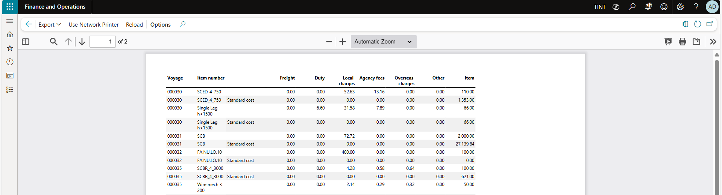

# 5.0 Request for quotation for export processes

The request for quotation is a standard process in Microsoft Dynamics 365 finance and operations. For the logistics team, requests for quotation will be used to collect quotations from different shipping vendors. The request for quotation process requires registering the answers from the vendor to compare and select a winning bid. This will help in creating purchase orders with the winning vendor automatically.

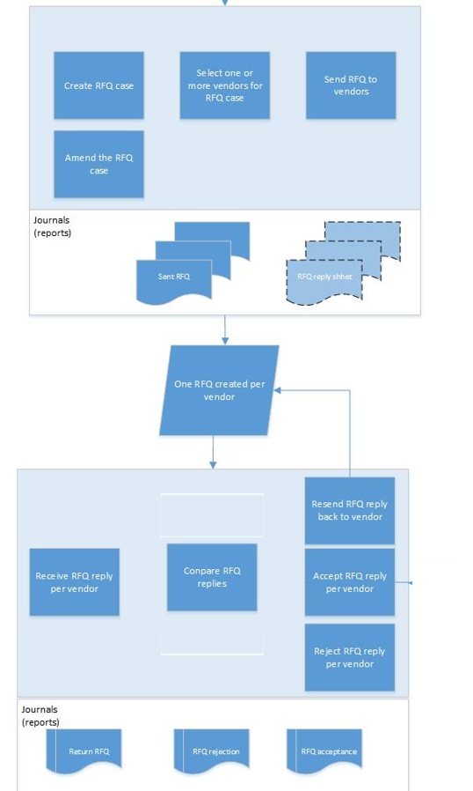

1. Navigate project management and accounting > projects > all projects
2. Select the project
3. Under Manage > New > Item tasks. Select Request for quotation

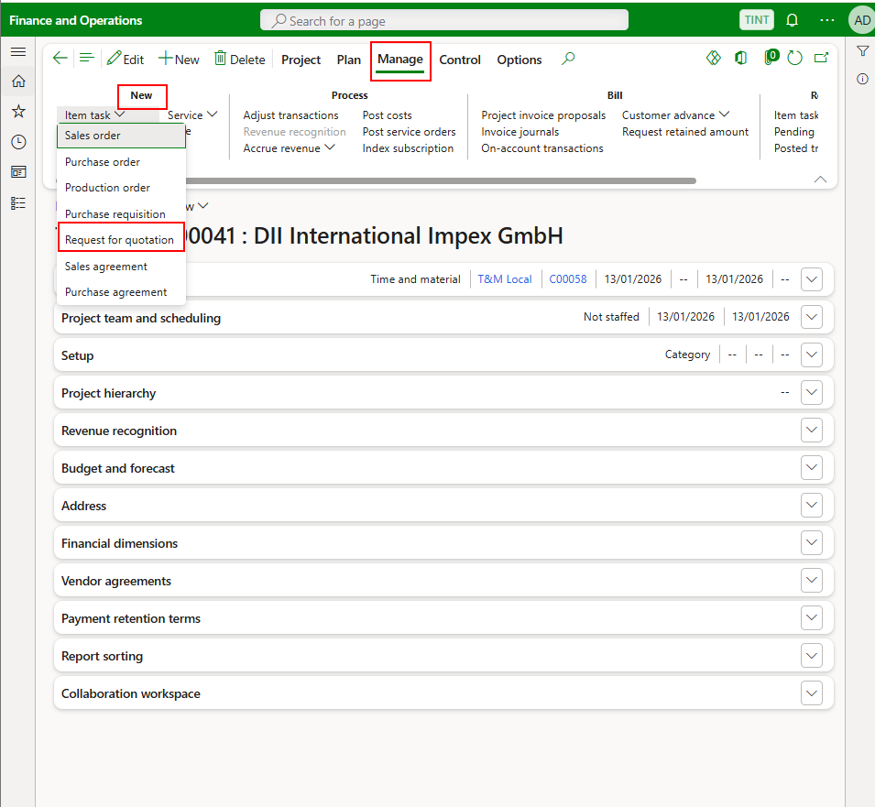

1. A dialogue will open with the Technica information. Press OK. Modify the requested receipt date if needed.

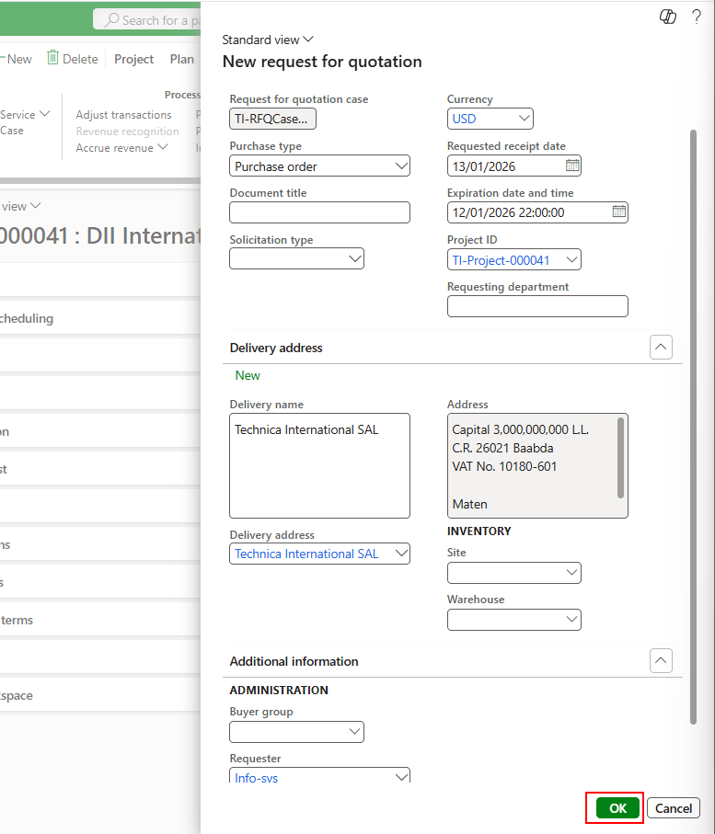

1. The request for quotation form will open. Under lines > request for quotation line, specify service item (Freight) in the line type.

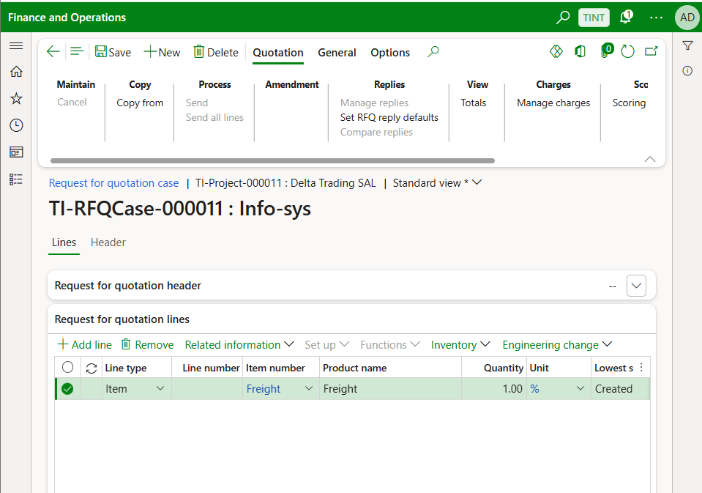

1. Enter the quantity and the text. The text can be the number of containers used, the type of containers, the mode of transport.

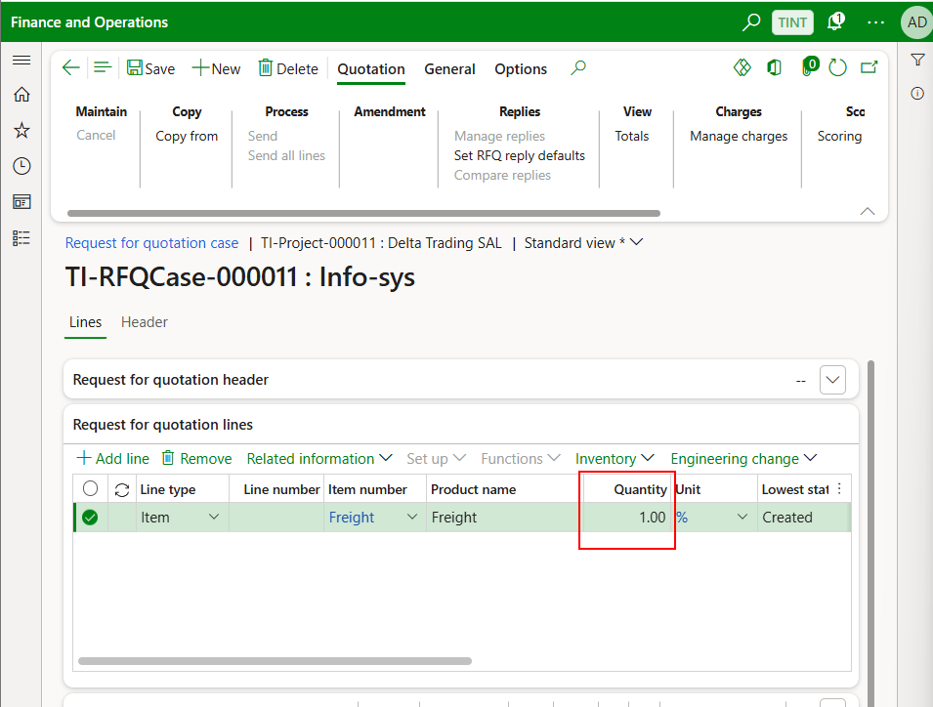

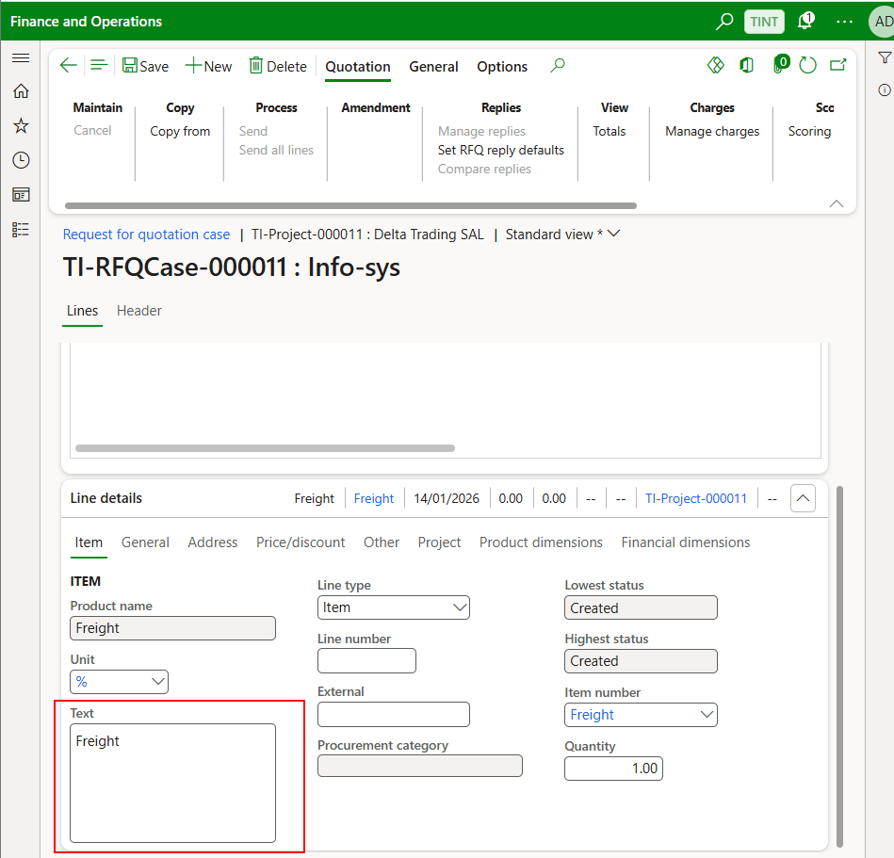

1. Under header > Vendor, specify the vendors invited to submit bids for this request for quotation.

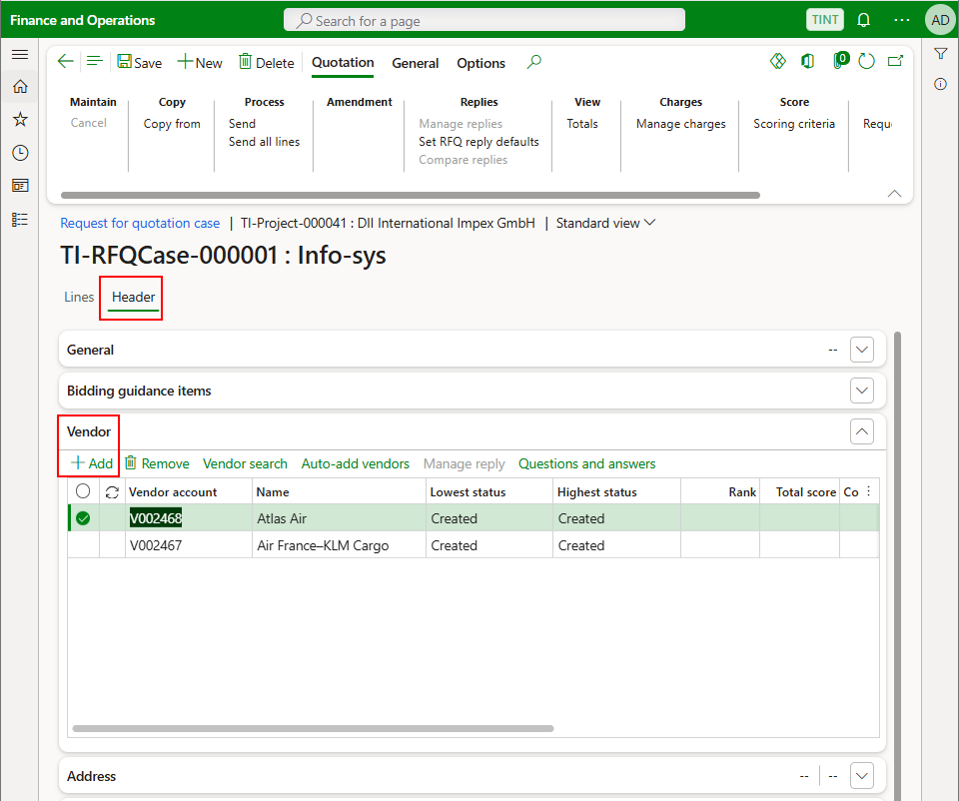

1. To send the quotation to the vendor, under quotation > process. Press Send.

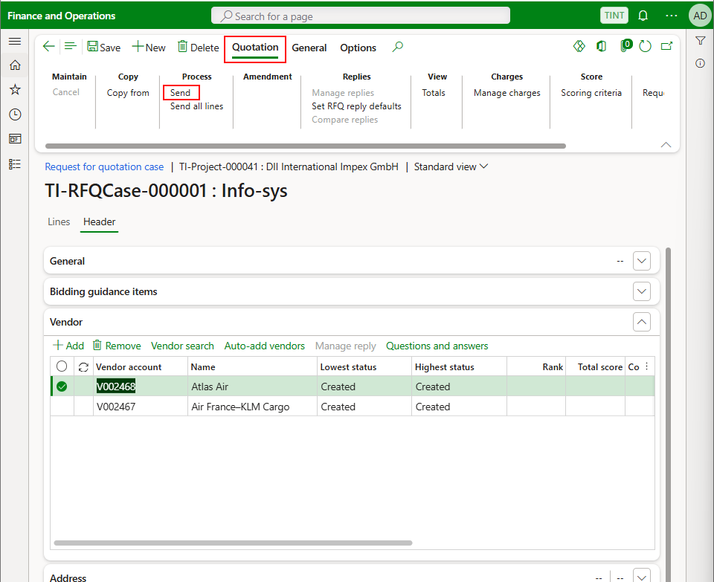

1. Press Ok to send

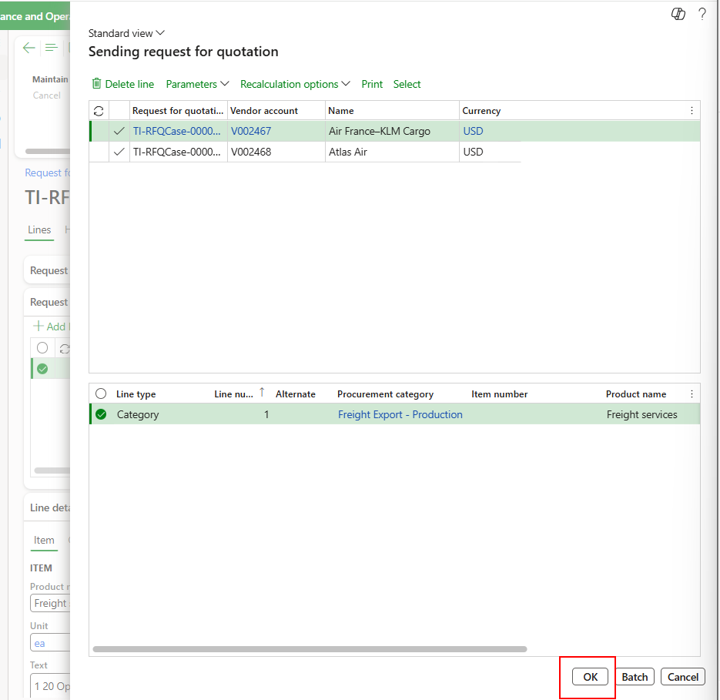

1. The status of the quotation is sent. The logistics team need to send emails to the vendors asking them to send back quotation.

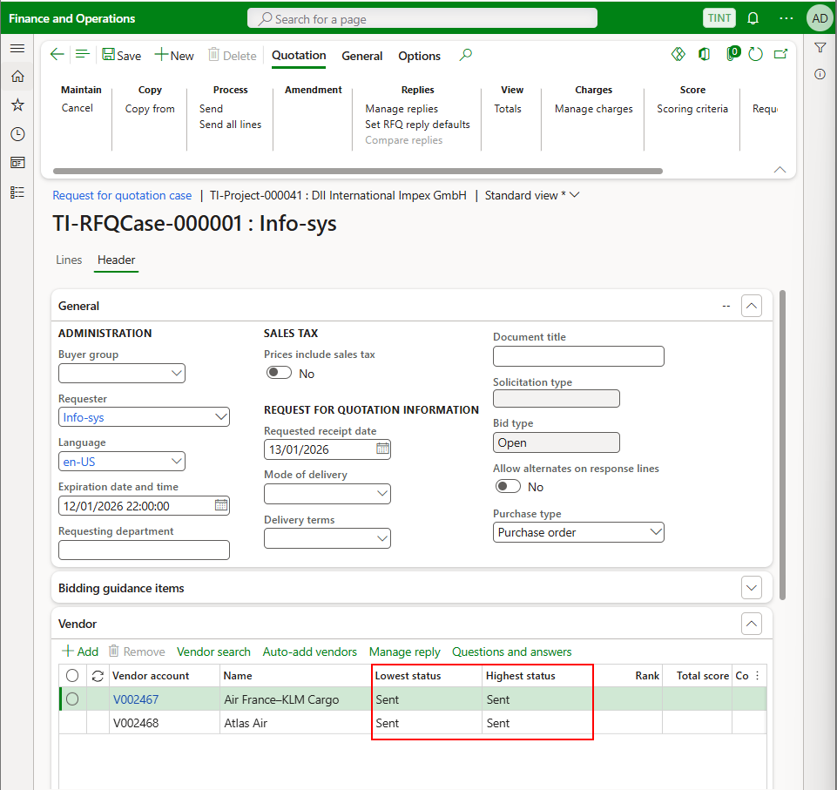

1. Once getting an answer from the vendor and to register it in the system. Under Quotation > Replies. Select Manage replies

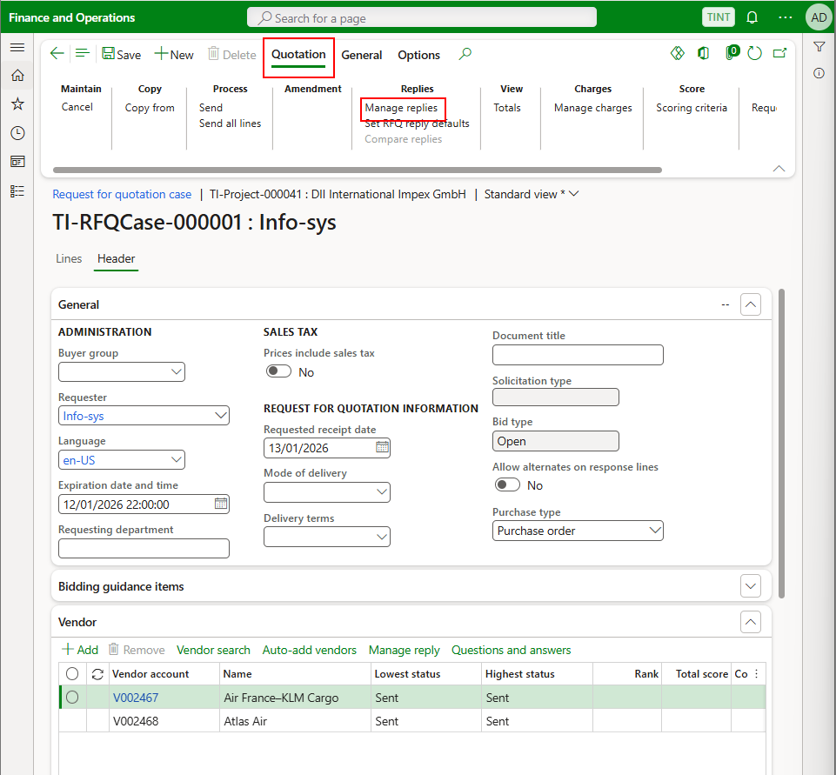

1. Select Edit > Edit RFQ reply

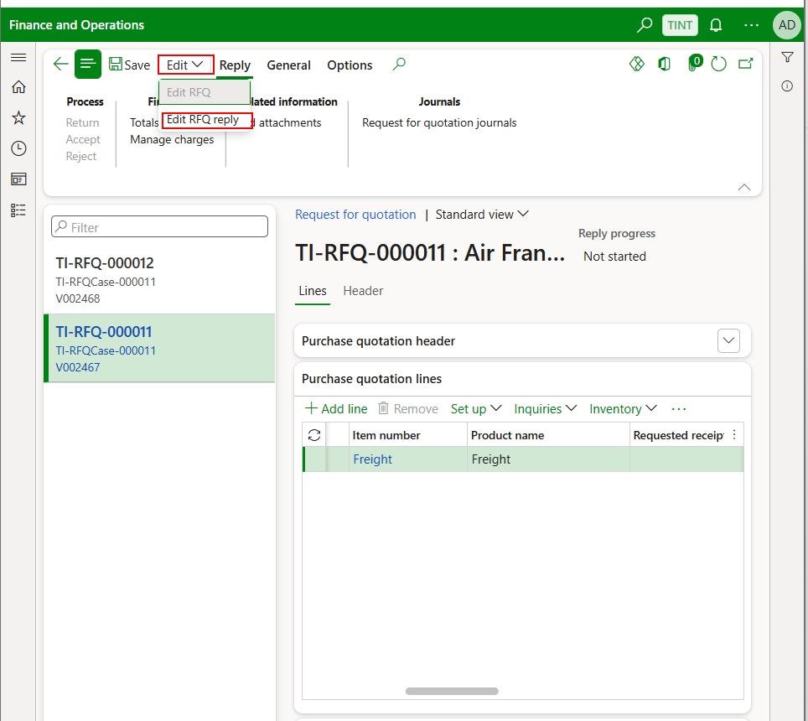

1. Enter the following information provided by the vendor

Price

Requested date by the vendor

Comments if applicable

Change the item description if applicable

Delivery terms

Mode of delivery

Terms of payment

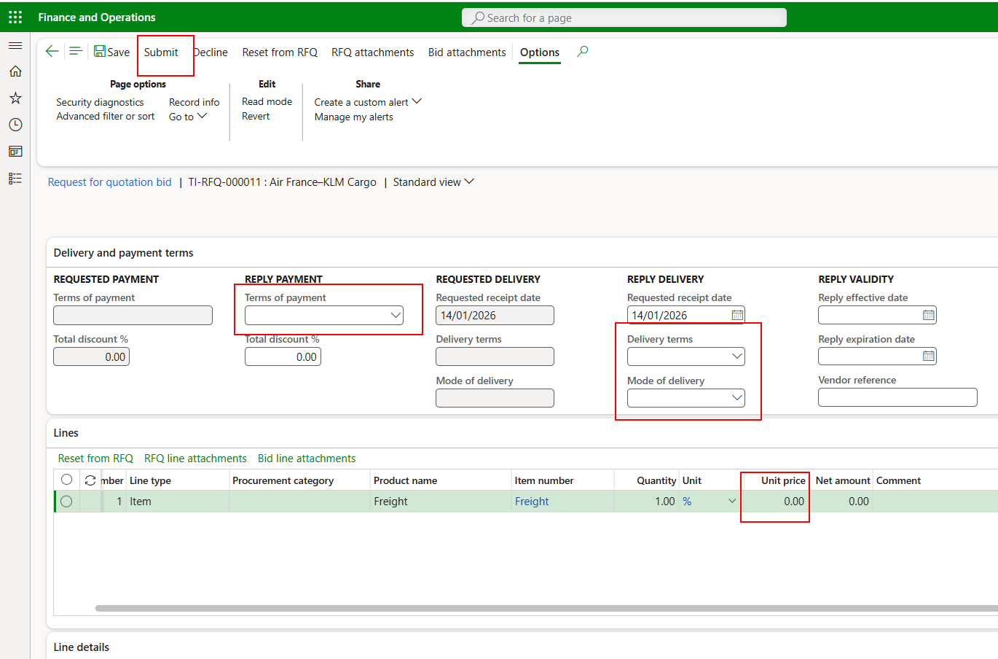

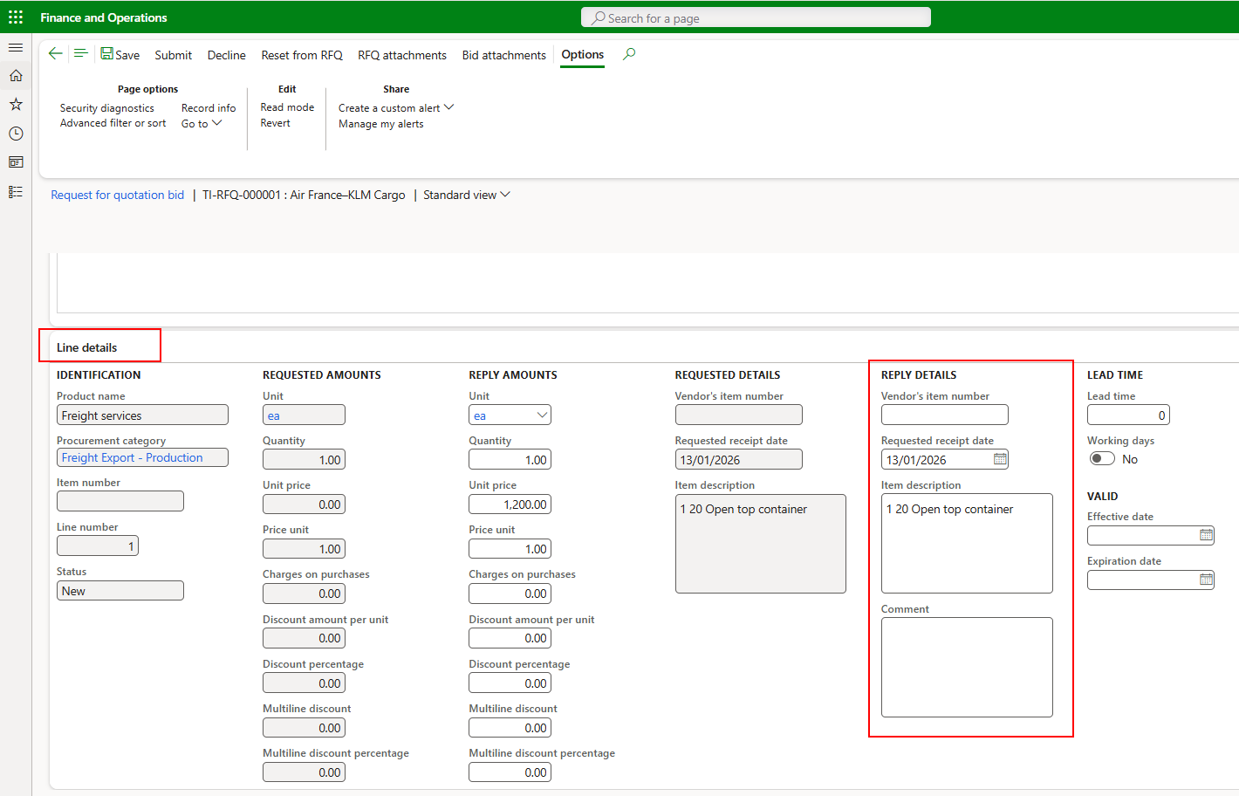

1. It is possible to add attachment to the bid through the bid attachments. These will remain at the level of the bid and will not be transferred to the purchase order once created.

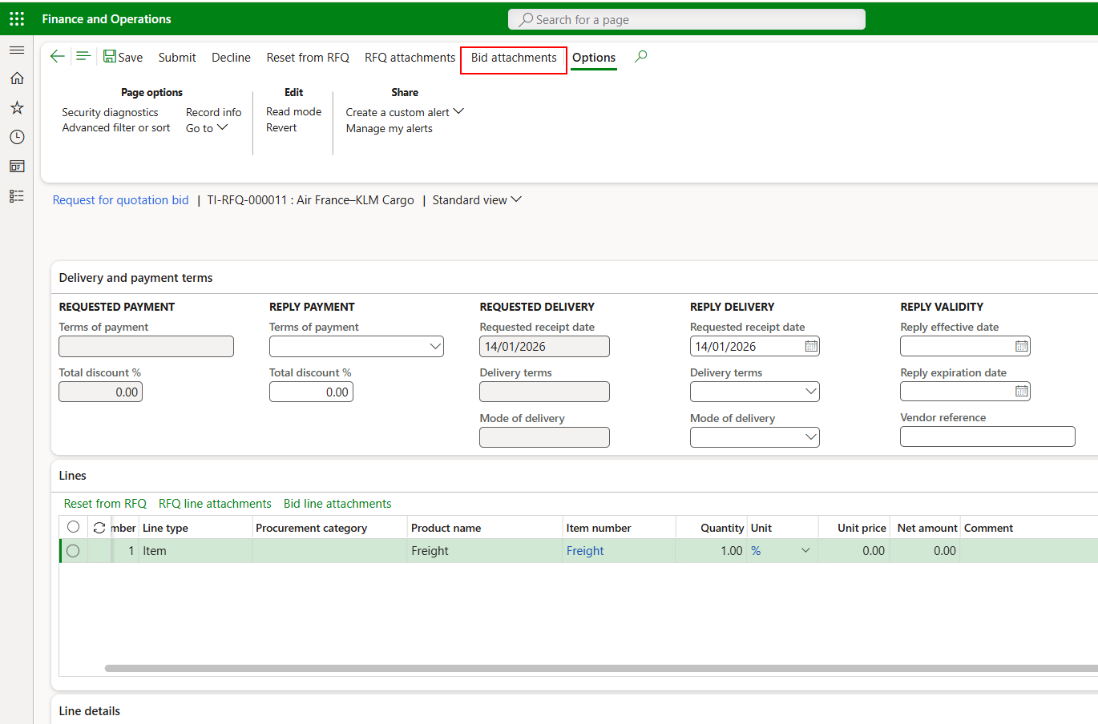

1. When done, submit the bid

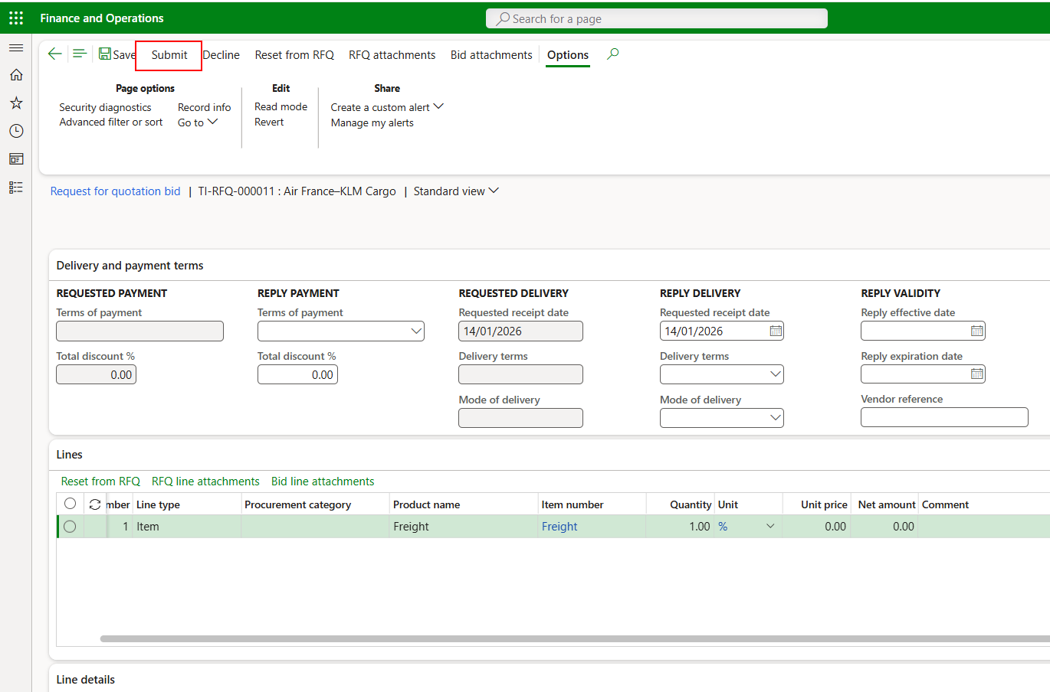

1. Do the same procedure for each vendor
2. After all the quotations have been submitted. Go back to the request for quotation to select the vendor. Under quotation > replies > compare replies

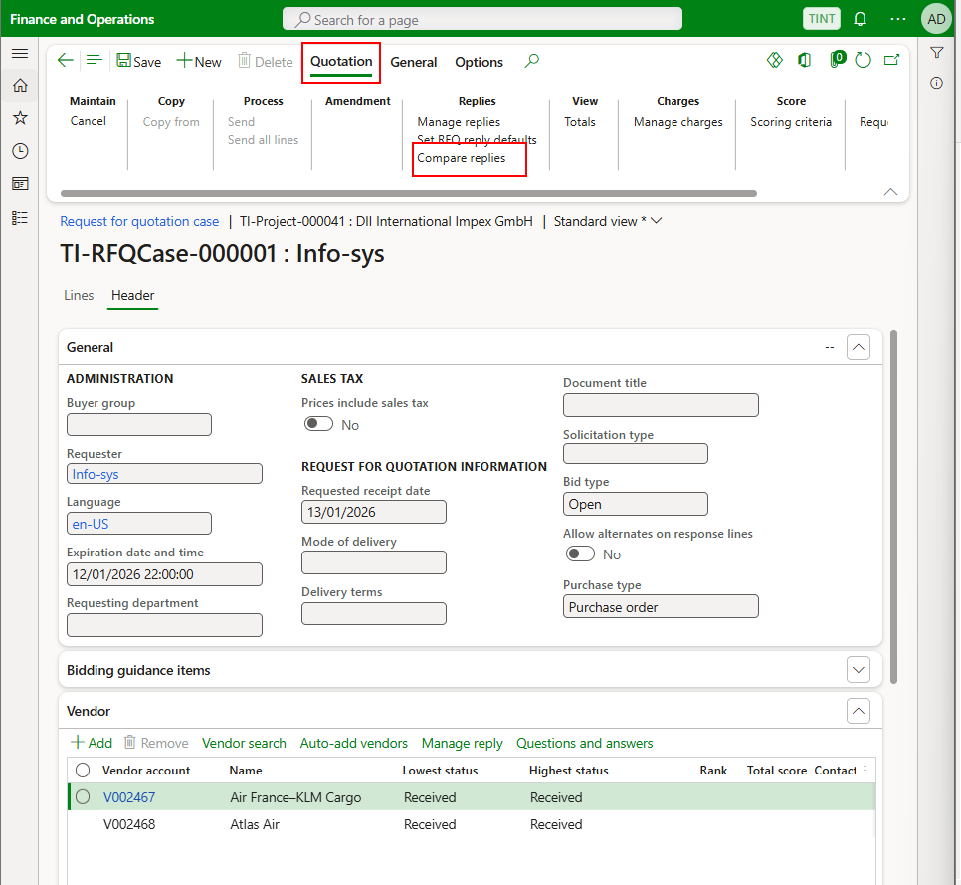

1. The compare replies screen gives better visibility for the different bids by the vendor and makes it easier for the logistics team to select the most suitable one.

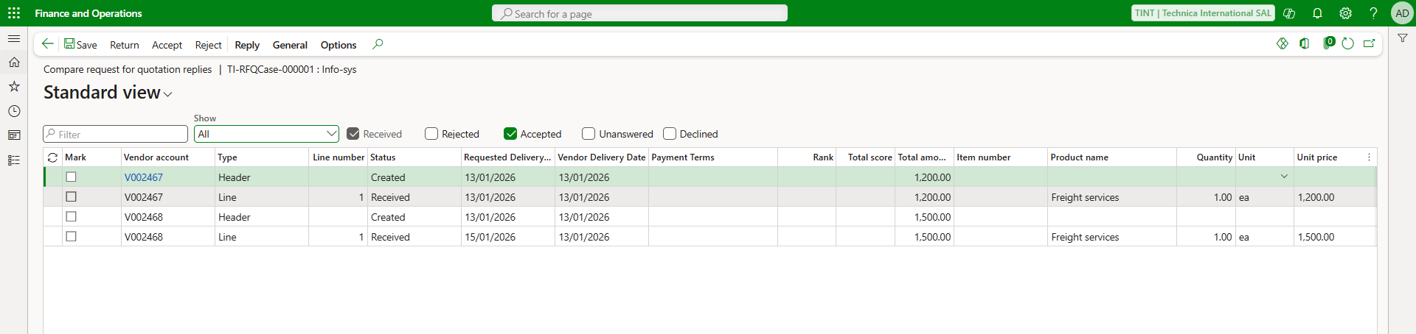

1. After accepting the bid, a purchase order is auto created, and it requires processing**. Make sure to fill in the purchase pool in the purchase order header to classify if the purchase order is for export or import.**

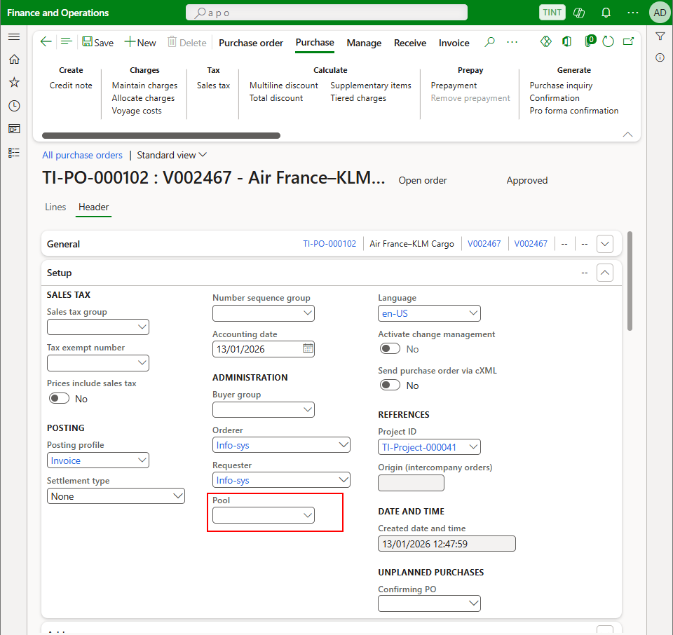

1. For processing a purchase order, refer to the procurement training manual.